NAME: ALI MOHAMED ALI
ID: C6240324
CLASS: CNS242

CHAPTER 1 – Linux Commands, Definitions, Options and Practice
Below are the 12 Linux commands with their definitions, purposes, syntax, available options and practical examples.
1. whoami
Definition:
The whoami command displays the username of the currently logged-in user. It helps you identify which user account is currently running commands in the Linux terminal.
Why Students Use This Command:
- To identify the current user.
- To check which account is being used.
- To understand user identity in Linux.
- Options and Shortcuts
Option | Function
--help | Displays help information.
--version | Displays the command version.
- Practice – Terminal
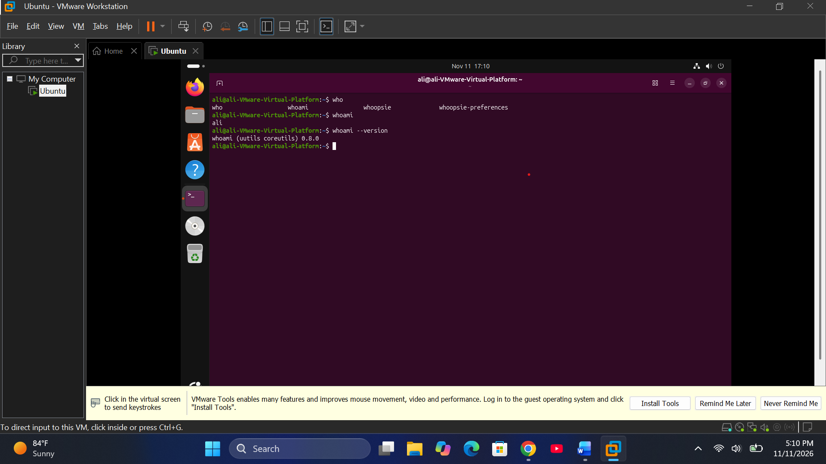
2. pwd
Definition:
The pwd command stands for Print Working Directory. It displays the full path of the directory you are currently working in.
Why Students Use This Command:
- To know their current location.
- To identify the full directory path.
- To navigate directories correctly
- Options and Shortcuts
Option | Function
-L | Displays the logical current directory path.
-P | Displays the physical directory path.
--help | Displays help information.
--version | Displays the command version.
- Practice – Terminal
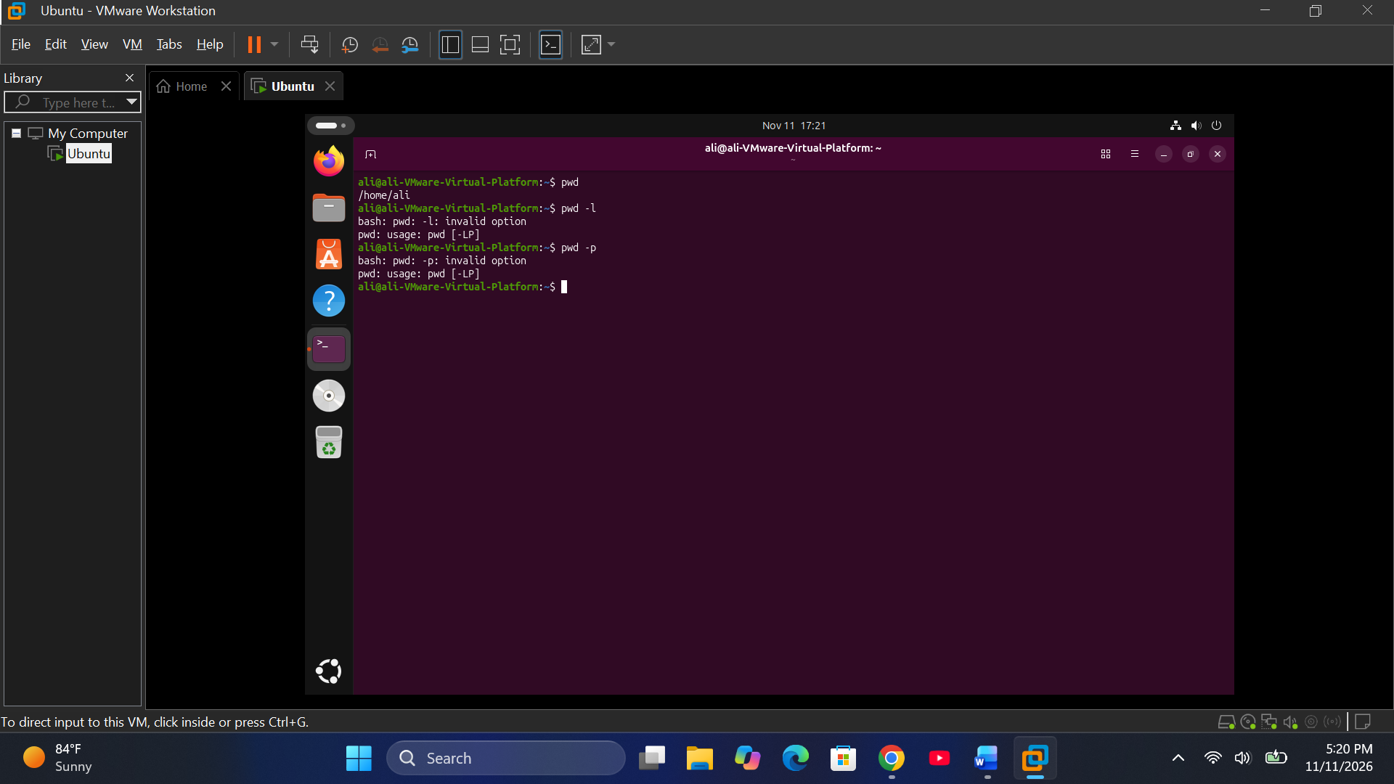
3. uname -r
Definition:
The uname command displays information about the operating system and kernel. The -r option displays the current Linux kernel release version.
Why Students Use This Command:
- To check the Linux kernel version.
- To identify system information.
- To troubleshoot system compatibility.
Options and Shortcuts
Option | Function
-a | Displays all available system information.
-r | Displays the kernel release.
-s | Displays the kernel name.
-n | Displays the network hostname.
-m | Displays the machine hardware name.
-v | Displays kernel version details.
-o | Displays the operating system.
-p | Displays the processor type, if available.
Practice – Terminal

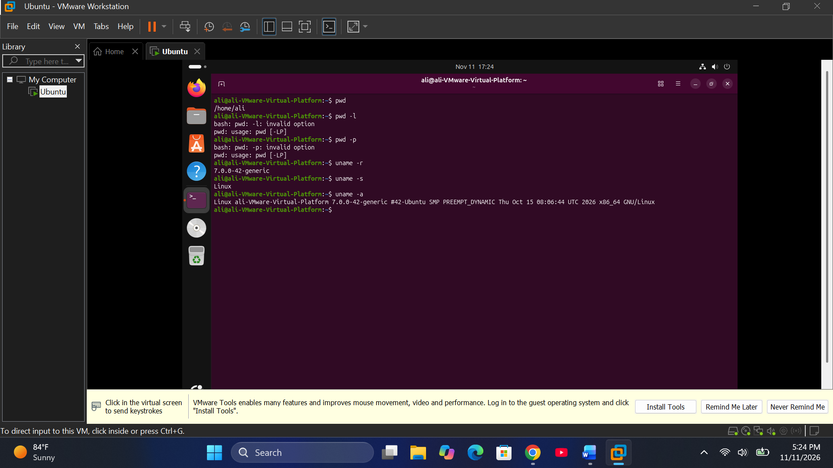
4. cat /etc/os-release
Definition:
The cat command displays the contents of a file. The /etc/os-release file contains information about the installed Linux distribution, including its name and version.
Why Students Use This Command:
- To identify the Linux distribution.
- To check the Ubuntu version.
- To read configuration files
- Options and Shortcuts
Option | Function
-n | Numbers all lines.
-b | Numbers non-empty lines.
-s | Removes repeated empty lines from output.
-A | Displays non-printing characters visibly.
-E | Shows the end of each line.
-T | Displays tab characters visibly.
-v | Displays non-printing characters.
- Practice – Terminal
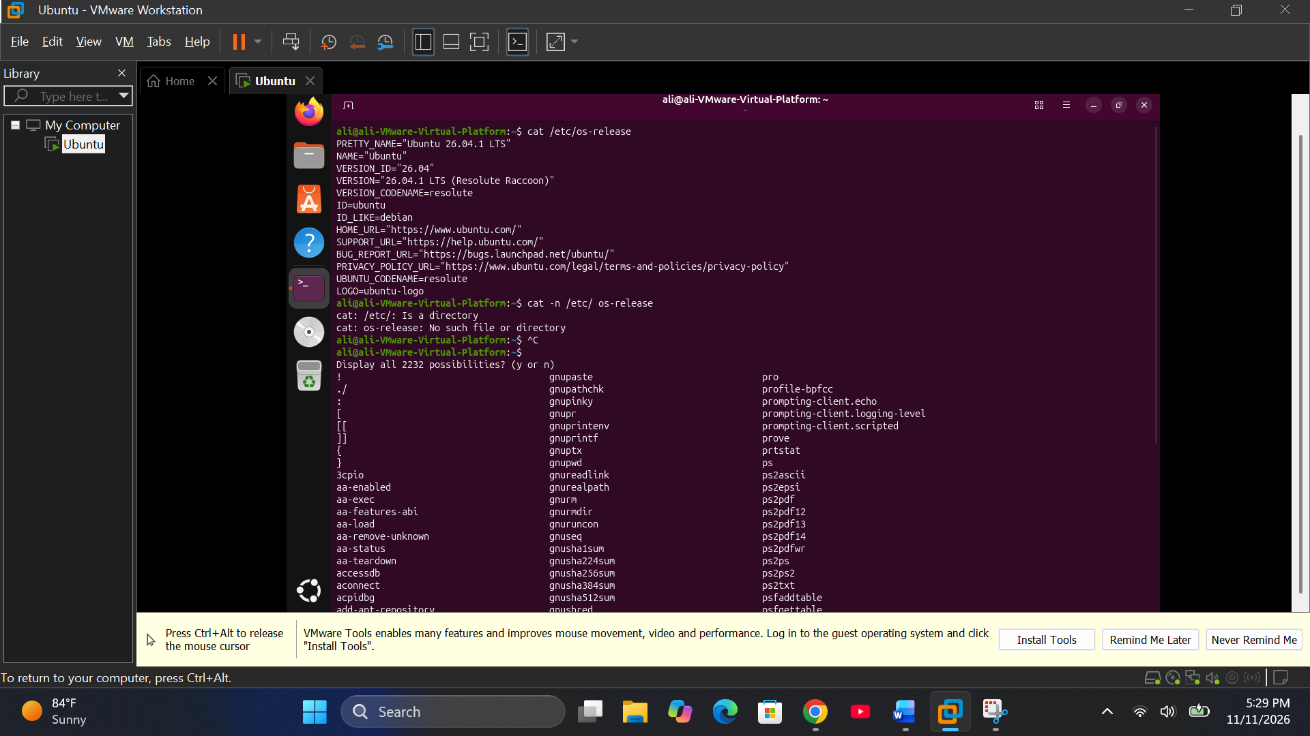
5. ls
Definition:
The ls command stands for List. It displays files and directories inside the current directory or another specified directory.
Why Students Use This Command:
- To view files and folders.
- To identify hidden files.
- To check file permissions and sizes.
- To organize and manage directories.
- Options and Shortcuts
Option | Function
-a | Displays all files, including hidden files.
-l | Displays files in long format.
-h | Displays file sizes in human-readable format.
-R | Lists directories recursively.
-t | Sorts files by modification time.
-S | Sorts files by size.
-r | Reverses the sorting order.
-i | Displays inode numbers.
-d | Displays directory information instead of its contents.
-1 | Displays one file per line.
- Practice – Terminal
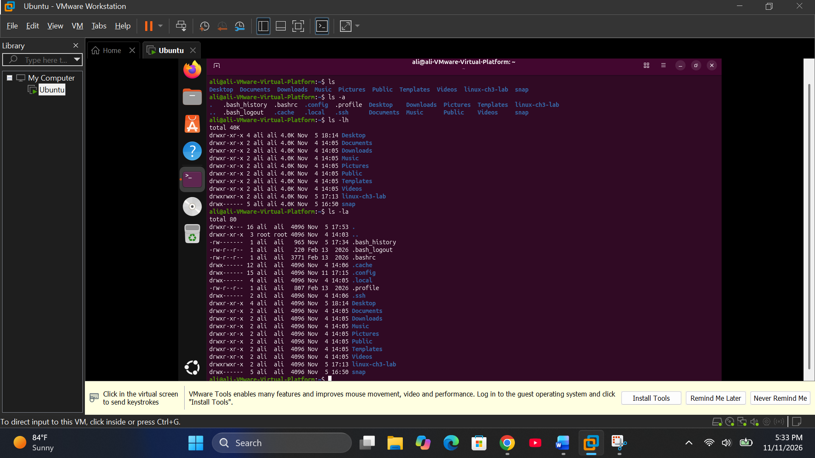
6. cp
Definition:
The cp command stands for Copy. It is used to copy files and directories from one location to another without removing the original file.
Why Students Use This Command:
- To create backup files.
- To duplicate files and folders.
- To transfer files between directories.
- Options and Shortcuts
Option | Function
-r | Copies directories recursively.
-R | Copies directories recursively.
-i | Asks before overwriting files.
-f | Forces overwriting where possible.
-n | Prevents overwriting existing files.
-v | Displays copied files.
-u | Copies when the source is newer or destination is missing.
-p | Preserves file permissions, ownership and timestamps where possible.
-a | Preserves file attributes and copies recursively.
-b | Creates a backup before overwriting.
- Practice – Terminal
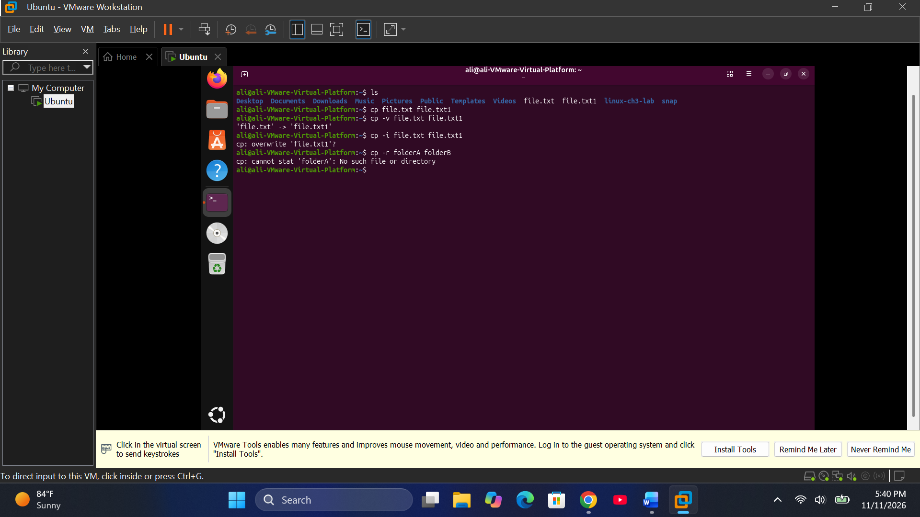
7. mv
Definition:
The mv command stands for Move. It is used to move files and directories from one location to another. It can also rename files and directories.
Why Students Use This Command:
- To move files between directories.
- To rename files and folders.
- To organize files
- Options and Shortcuts
Option | Function
-i | Asks before overwriting.
-f | Forces overwriting where possible.
-n | Prevents overwriting existing files.
-v | Displays moved files.
-u | Moves when the source is newer or destination is missing.
-b | Creates a backup before overwriting.
-t | Specifies the target directory.
-T | Treats the destination as a normal file, not a directory.
- Practice – Terminal
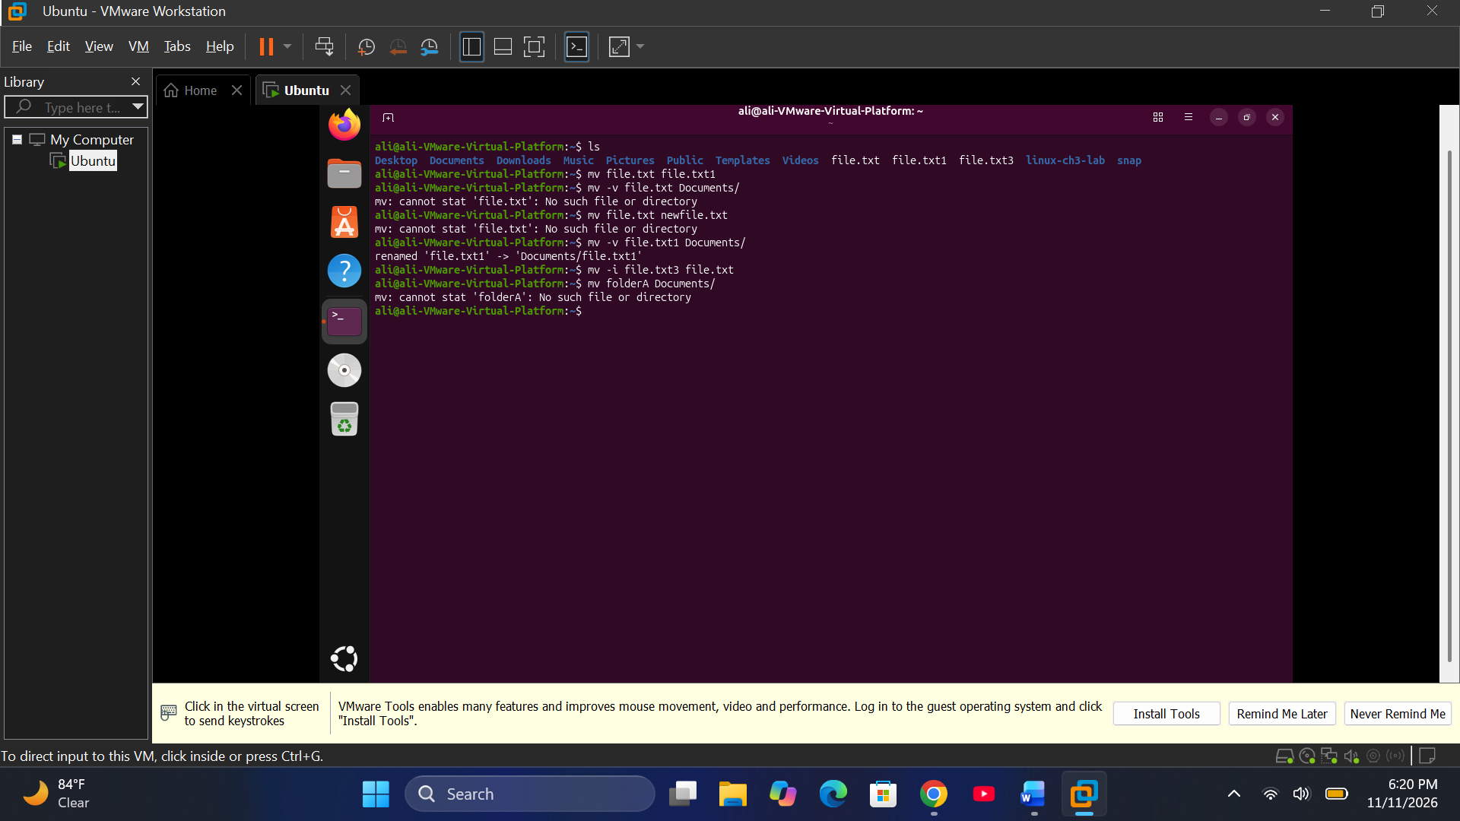
8. apt
Definition:
The apt command stands for Advanced Package Tool. It is the main package management command used in Ubuntu and Debian-based Linux distributions. It installs, updates, upgrades and removes software packages.
Why Students Use This Command:
- To install new software.
- To update package information.
- To upgrade installed applications.
- To remove unnecessary software.
- Options and Shortcuts
Option / Command | Function
update | Updates package lists.
upgrade | Upgrades installed packages.
install | Installs a package.
remove | Removes a package.
purge | Removes a package and its configuration files.
autoremove | Removes unnecessary dependencies.
search | Searches for packages.
show | Displays package information.
-y | Automatically answers yes to confirmation prompts.
-s | Simulates an operation without making changes.
-q | Reduces output messages.
--reinstall | Reinstalls an already installed package.
--no-install-recommends | Avoids installing recommended packages.
- Practice – Terminal
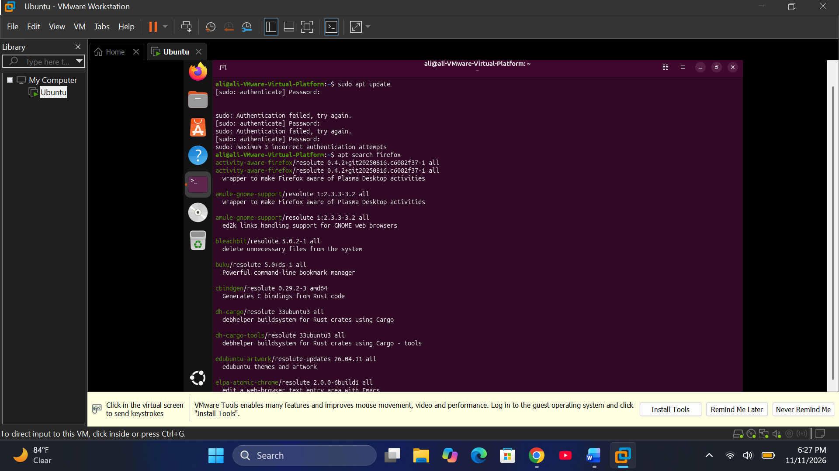
9. dpkg
Definition:
The dpkg command stands for Debian Package. It is a low-level package management tool used in Ubuntu and Debian Linux. It manages .deb installation files and installed packages.
Why Students Use This Command:
- To install .deb files.
- To remove installed packages.
- To check installed packages.
- To inspect package information.
- Options and Shortcuts
Option | Function
-i | Installs a .deb package.
-r | Removes an installed package.
-P | Removes a package and its configuration files.
-l | Lists packages and their status.
-L | Lists files belonging to a package.
-s | Displays package status.
-S | Finds which package owns a file.
-c | Lists files inside a .deb archive.
-I | Displays information about a .deb archive.
--configure | Configures an unpacked package.
- Practice – Terminal
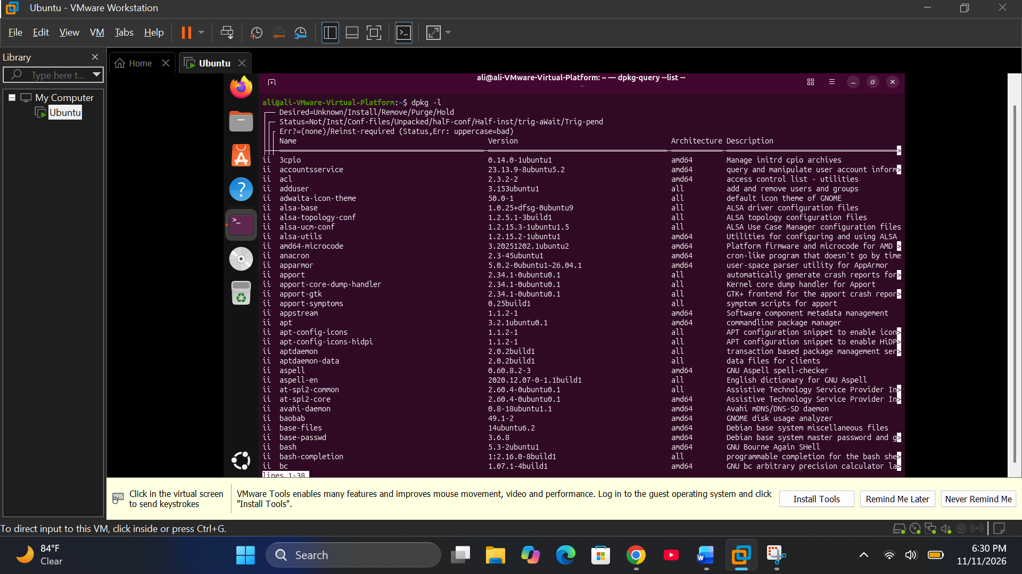
No. | Command | Main Function
1 | whoami | Displays current username.
2 | pwd | Displays current directory.
3 | uname -r | Displays kernel release.
4 | cat | Displays file contents.
5 | ls | Lists files and directories.
6 | cp | Copies files and directories.
7 | mv | Moves or renames files.
8 | apt | Manages Ubuntu packages.
9 | dpkg | Manages Debian packages.
10 | dnf | Manages Fedora packages.
11 | yum | Manages RPM packages.
12 | zypper | Manages openSUSE packages.
Important for Ubuntu VMware
Your Ubuntu system mainly uses apt and dpkg.
The commands dnf, yum and zypper are designed for other Linux distributions. You can use their --help commands to study them in Ubuntu, but their package-management operations will not normally work unless the relevant tools and repositories are installed.
Study tip: Learn the definition, syntax and options of each command, then practise the terminal examples. This will help you prepare for both written and practical Linux examinations.

CHAPTER 2 – Linux Commands, Definitions, Options and Practice
- ls
Definition:
The ls command stands for List. It displays files and directories in the current directory or a specified location.
Why Students Use This Command:
- To view files and folders.
- To identify hidden files.
- To check file permissions and sizes.
- To organize directories.
options and Shortcuts
Option | Function
-a | Shows all files, including hidden files.
-l | Displays detailed information.
-h | Shows file sizes in human-readable format.
-la | Shows all files with detailed information.
-lh | Shows detailed information with readable sizes.
-R | Lists directories recursively.
-t | Sorts files by modification time.
-S | Sorts files by size.
-r | Reverses sorting order.
-i | Displays inode numbers.
-d | Displays directory information itself.
- Practice – Terminal
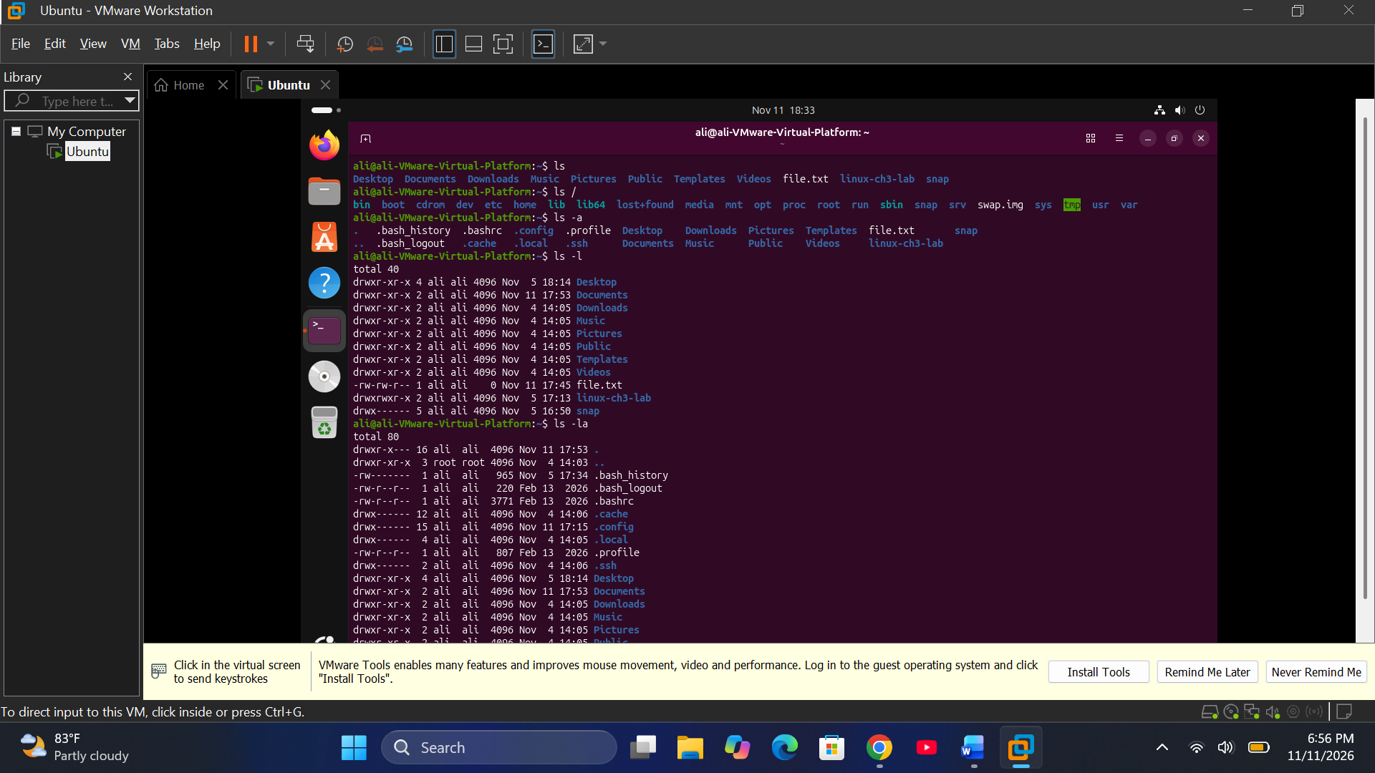
3. cd
Definition:
The cd command stands for Change Directory. It is used to move from one directory to another in the Linux filesystem.
Why Students Use This Command:
- To navigate between folders.
- To access files in different locations.
- To move to the home directory or parent directory.
- Options and Shortcuts
Command | Function
cd | Returns to the home directory.
cd ~ | Opens the home directory.
cd .. | Moves to the parent directory.
cd - | Returns to the previous directory.
cd /etc | Opens the /etc directory.
cd /var/log | Opens the system log directory.
cd ~/Documents | Opens Documents inside the home directory.
cd /home/student/Downloads | Opens the specified Downloads directory.
cd ../Downloads | Opens Downloads inside the parent directory.
cd . | Stays in the current directory.
- Practice – Terminal
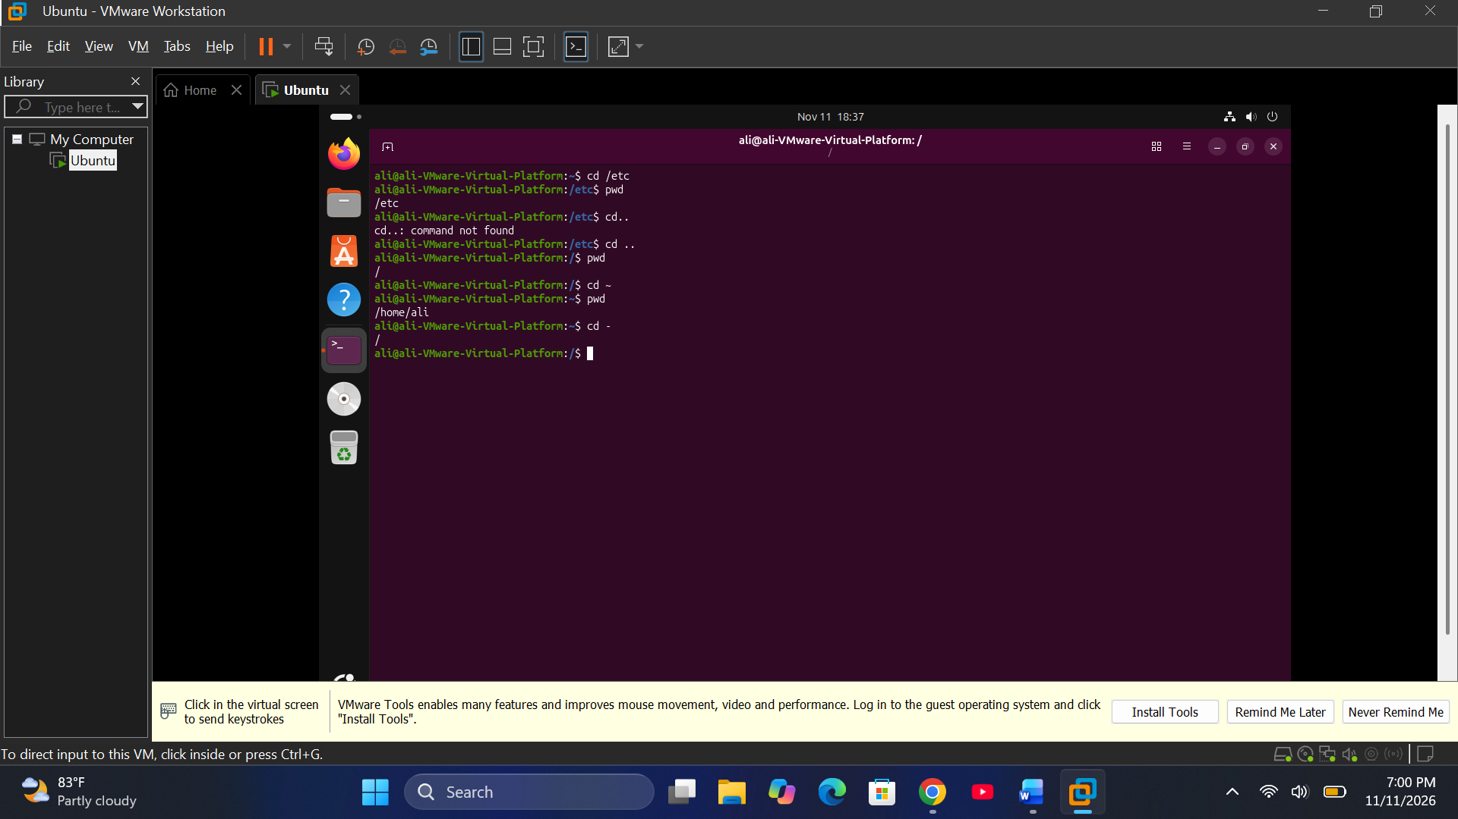
2. Help Commands
Help commands provide information about Linux commands, their usage, syntax and available options.
4. man
Definition:
The man command stands for Manual. It displays the official manual pages of Linux commands and explains how they work.
Why Students Use This Command:
- To learn command syntax.
- To understand command options.
- To find detailed information about commands.
- Options and Shortcuts
Command | Function
man ls | Displays the manual for ls.
man grep | Displays the manual for grep.
man cd | Searches for the manual of cd.
man 1 passwd | Displays the user command manual for passwd.
man 5 passwd | Displays the manual for the passwd configuration file format.
-k | Searches manual descriptions by keyword.
-f | Displays a short manual description.
- Important Manual Sections
Section | Meaning
1 | User commands
2 | System calls
3 | Library functions
4 | Special files
5 | File formats and configuration files
8 | System administration commands
- Practice – Terminal
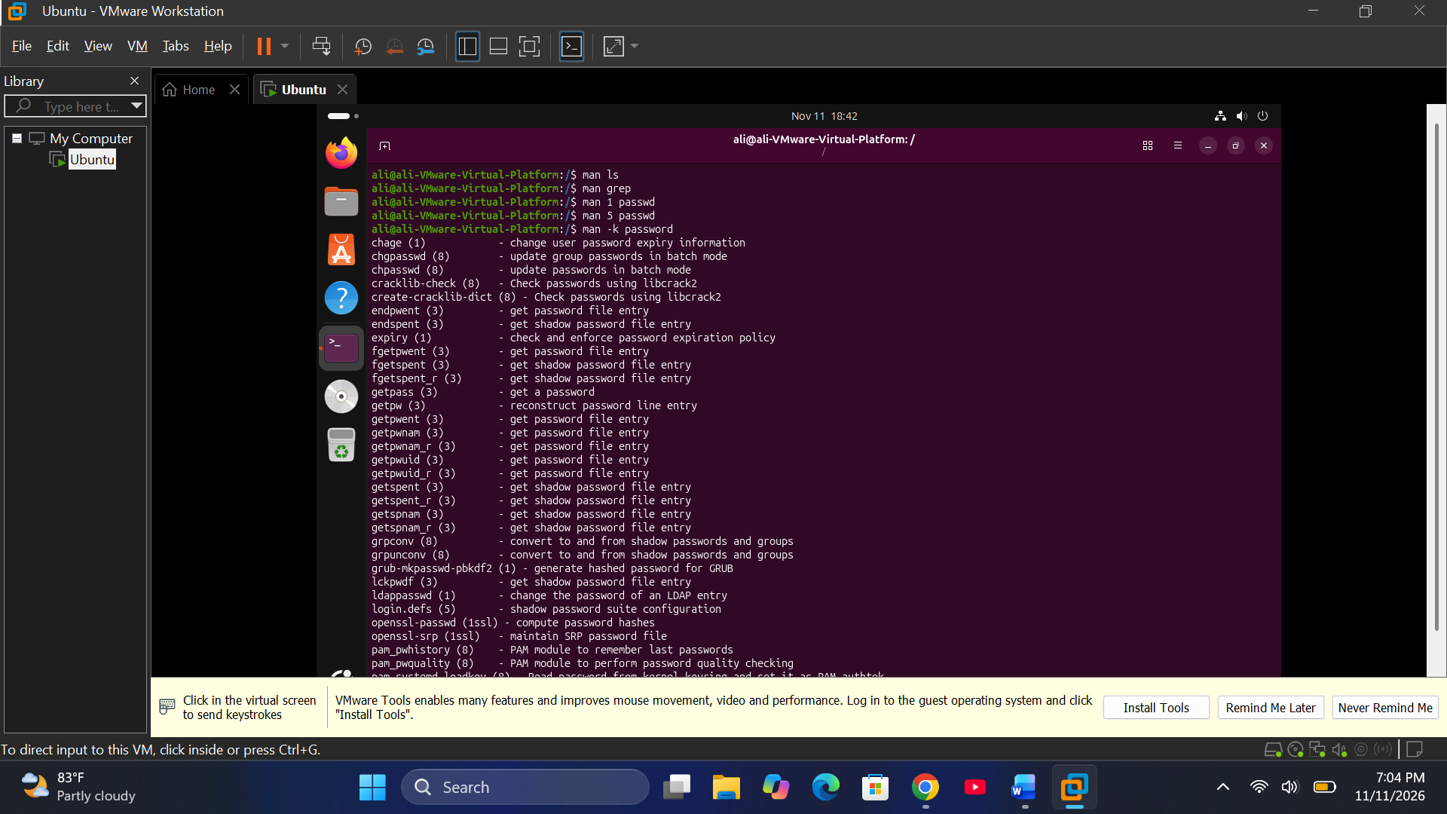

Press q to exit a manual page.
5. --help
Definition:
The --help option displays a short explanation of a command, including its syntax and available options.
Why Students Use This Command:
- To quickly understand a command.
- To find available options.
- To learn command usage without opening a manual page.
- Options and Shortcuts
Command | Function
mkdir --help | Displays help for mkdir.
ls --help | Displays help for ls.
cp --help | Displays help for cp.
mv --help | Displays help for mv.
- Practice – Terminal
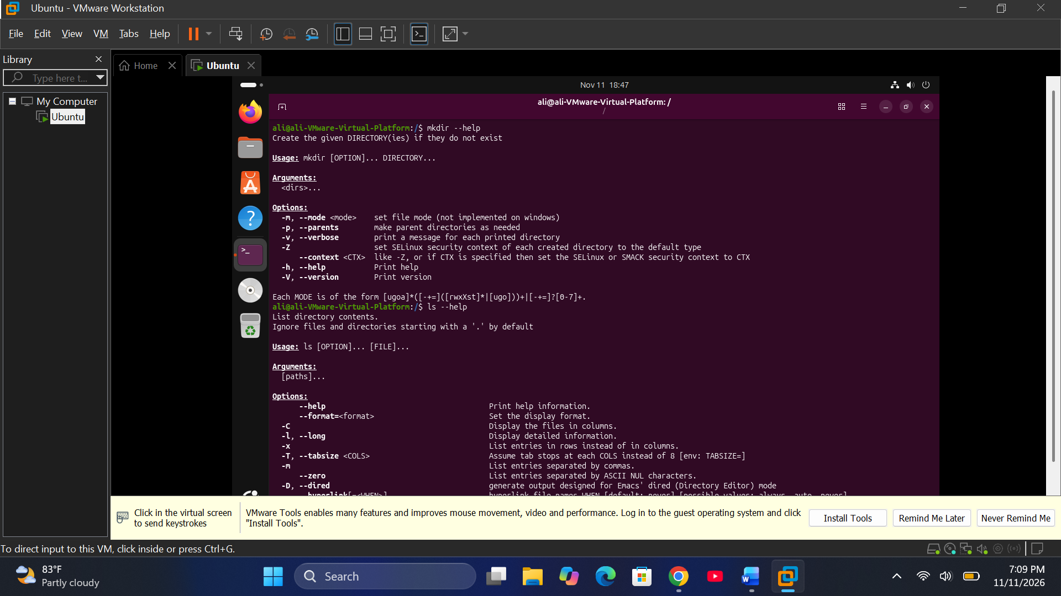
6. info
Definition:
The info command displays detailed documentation about Linux commands using the GNU Info documentation system.
Why Students Use This Command:
- To read detailed command documentation.
- To understand advanced command features.
- To learn how Linux tools work.
- Options and Shortcuts
Command / Option | Function
info ls | Opens documentation for ls.
-k | Searches Info documentation by keyword.
-f | Specifies an Info file to open.
-h | Displays help information.
3. History and Terminal Commands
8. history
Definition:
The history command displays a list of commands previously entered in the Bash terminal.
Why Students Use This Command:
- To review previously executed commands.
- To repeat old commands.
- To remember commands used during practice.
- Options and Shortcuts
Option | Function
-c | Clears the current shell history list.
-d | Deletes a specific history entry.
-w | Writes the current history to the history file.
-r | Reads the history file.
-a | Appends new history entries to the history file.
- Practice – Terminal
- 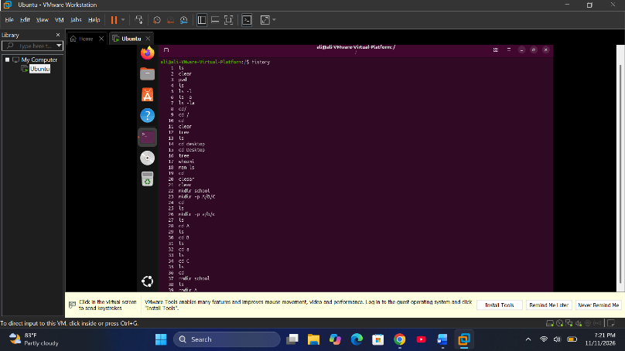

9. echo $SHELL
Definition:
The echo command displays text or variable values in the terminal. $SHELL is an environment variable that normally contains the path of the user's login shell.
Why Students Use This Command:
- To display text.
- To check the login shell.
- To display environment variables.
- Options and Shortcuts
Option | Function
-n | Prevents a new line after output.
-e | Enables interpretation of escape characters.
-E | Disables interpretation of escape characters.
- Practice – Terminal
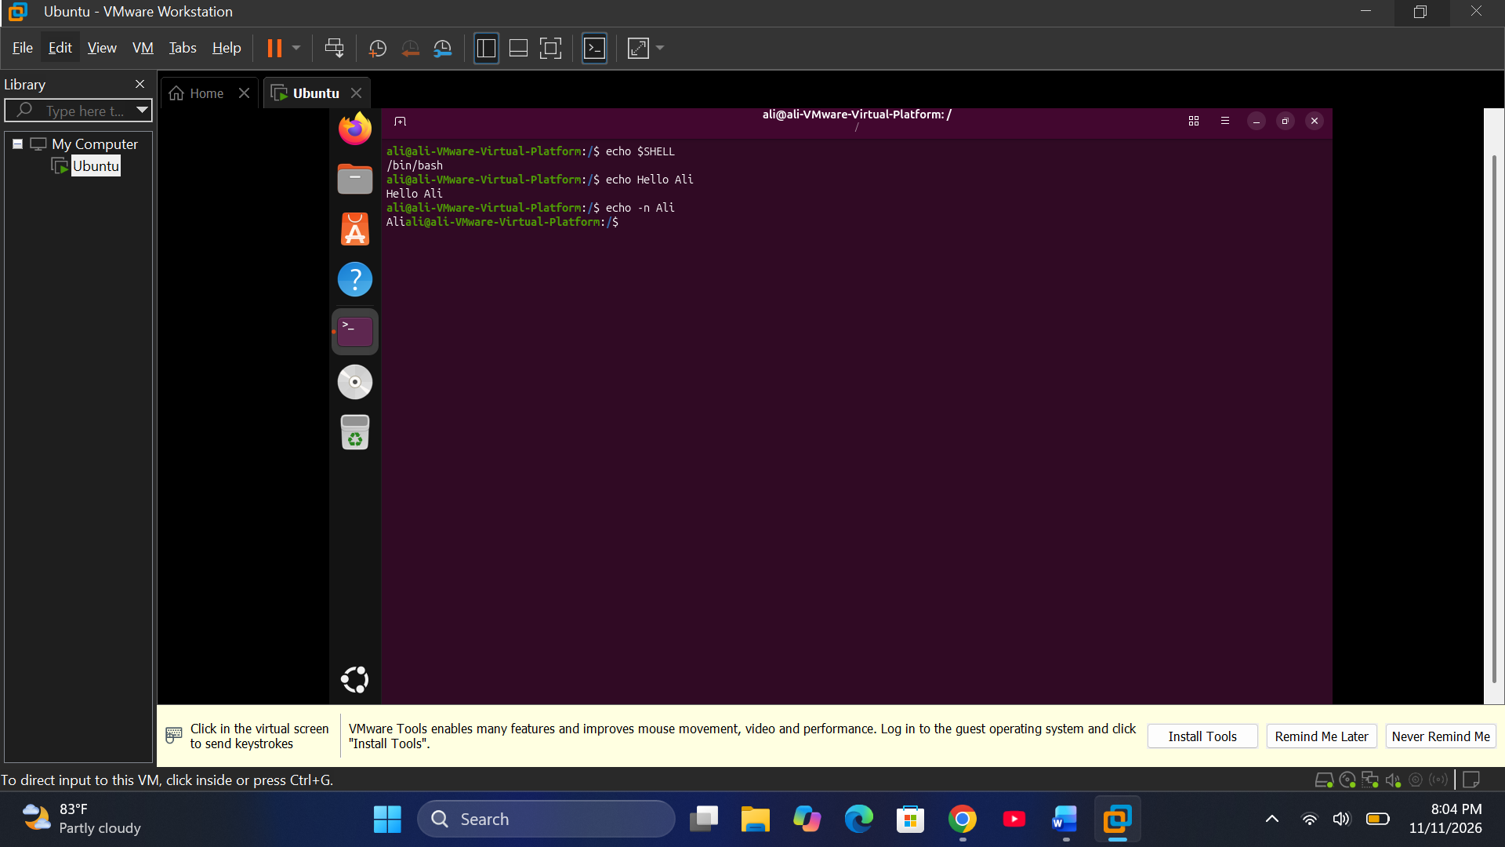
4. File and Directory Commands
10. touch
Definition:
The touch command creates an empty file if the file does not exist. If the file already exists, it updates its access and modification timestamps.
Why Students Use This Command:
- To create new empty files.
- To prepare files for writing.
- To update file timestamps.
- Options and Shortcuts
Option | Function
-a | Changes the access time.
-m | Changes the modification time.
-c | Does not create a file if it does not exist.
-t | Sets a specific timestamp.
-r | Uses another file's timestamps.
11. mkdir
Definition:
The mkdir command stands for Make Directory. It creates new directories (folders) in the Linux filesystem.
Why Students Use This Command:
- To organize files into folders.
- To create project directories.
- To create nested directories.
Options and Shortcuts
Option | Function
-p | Creates parent directories when necessary.
-v | Displays a message for each created directory.
-m | Sets directory permissions.
--help | Displays help information.

Practice – Terminal
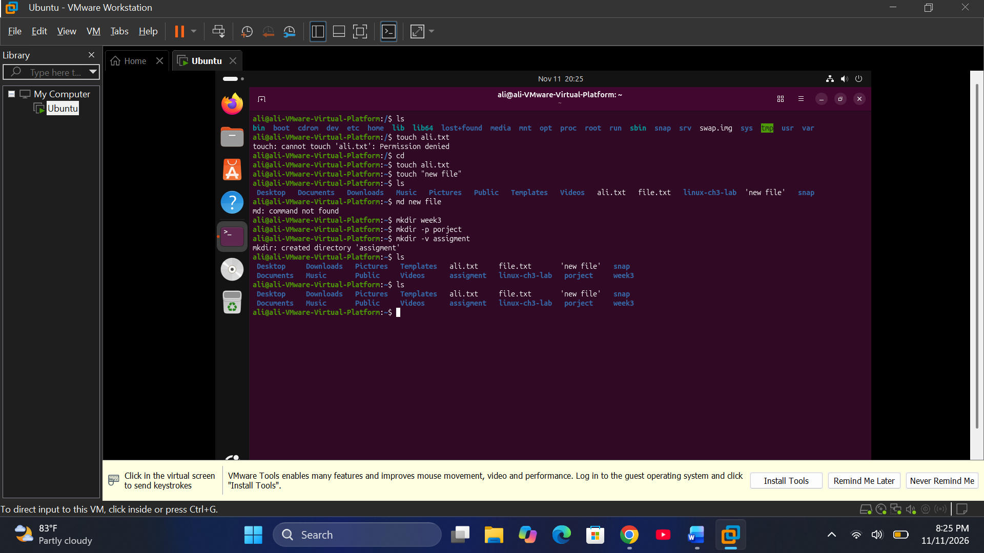
12. rmdir
Definition:
The rmdir command stands for Remove Directory. It removes empty directories from the Linux filesystem.
Why Students Use This Command:
- To remove unnecessary empty folders.
- To clean up directory structures.
- To manage folders.
- Options and Shortcuts
Option | Function
-p | Removes parent directories if they become empty.
-v | Displays a message for each removed directory.
--ignore-fail-on-non-empty | Ignores failures caused by non-empty directories.
5. Variables and PATH Commands
16. Variables
Definition:
A variable is a named storage location used to hold information such as text, numbers or configuration values. In Bash, variables can be created and accessed using the $ symbol.
Why Students Use This Command:
- To store information.
- To reuse values in commands.
- To understand environment variables.
- echo $NAME
- Important Variables
Variable | Function
COURSE | A user-created variable in this example.
$HOME | Displays the home directory.
$USER | Displays the current username.
$SHELL | Displays the login shell path.
$PATH | Displays directories searched for executable commands.
- Practice – Terminal
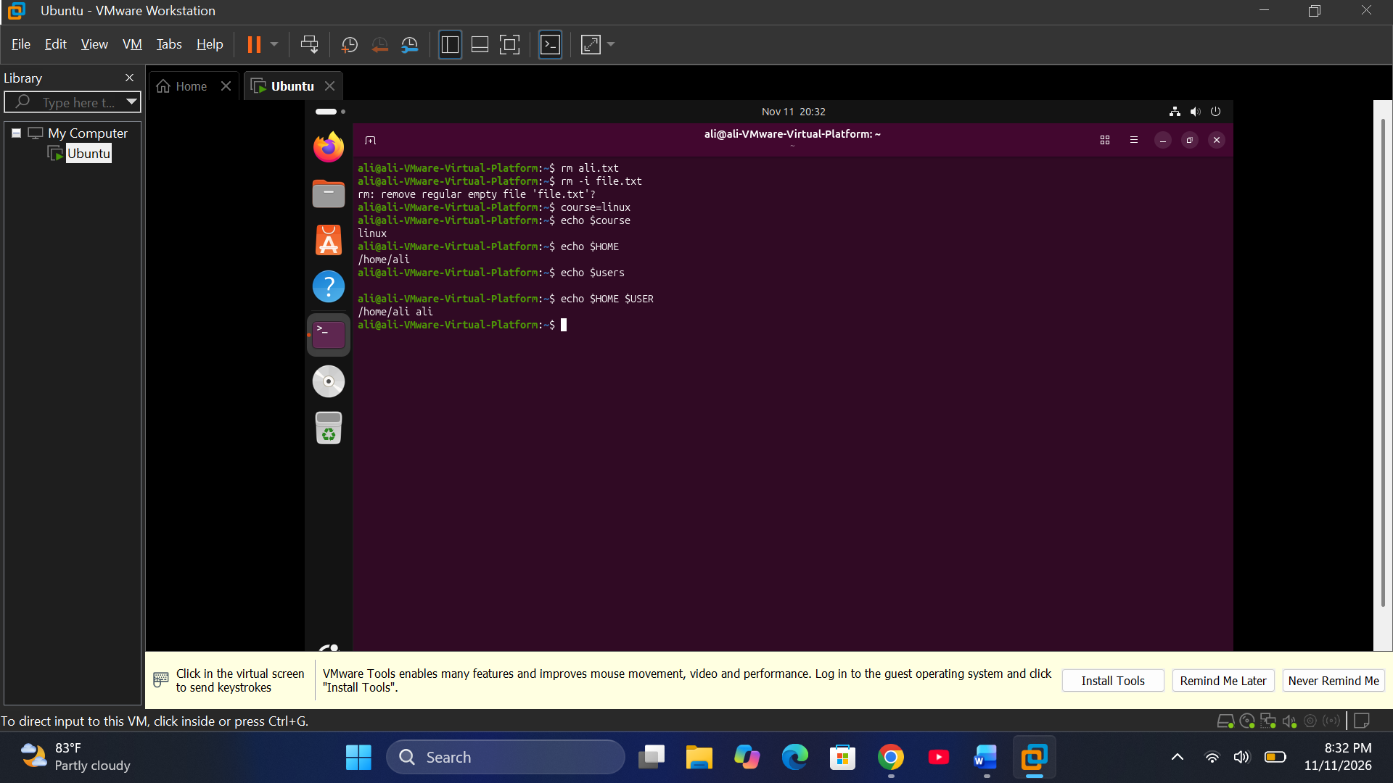
No. | Command | Main Function
1 | pwd | Shows current directory.
2 | ls | Lists files and directories.
3 | cd | Changes directory.
4 | man | Opens command manuals.
5 | --help | Displays command help.
6 | info | Opens detailed documentation.
7 | help | Displays Bash built-in help.
8 | history | Shows previous commands.
9 | echo | Displays text or variables.
10 | touch | Creates files or updates timestamps.
11 | mkdir | Creates directories.
12 | rmdir | Removes empty directories.
13 | cp | Copies files and directories.
14 | mv | Moves or renames files.
15 | rm | Deletes files and directories.
16 | export | Exports shell variables.
17 | PATH | Stores executable search directories.
18 | sudo | Runs commands with elevated privileges.
19 | source | Executes a file in the current shell.
20 | Wildcards | Match filenames using patterns.
21 | Quotes | Control how Bash interprets characters.
22 | . | Represents the current directory.
23 | .. | Represents the parent directory.
Important study advice: Practise the commands in your Ubuntu VMware terminal. Be especially careful with rm, rmdir, wildcards, sudo, and file-moving commands because they can change or delete your files.

Continued fromSawir Terminal Abuuris
CHAPTER 3 – LINUX COMMANDS 3.1 Viewing and Searching Files
cat
cat -n
less
more
head
head -n
tail
tail -n
tail -f
file
stat
ls -l
which
type
command -v
whereis
find
find -name
find -iname
find -type f
find -type d
find -size
find -mmin
locate
updatedb
grep
grep -n
grep -i
grep -v
grep -r
grep -rn
👋 3.2 Redirection, Pipes and Text Processing
>
>>
2>
<
|
;
&&
||
$?
sort
sort -n
sort -r
sort -rn
uniq
uniq -c
uniq -d
cut
cut -d
cut -f
cut -c
paste
paste -d
paste -s
wc
wc -l
wc -w
wc -c
wc -m
tr
tr -d
tr -s
👋 3.3 Archives and Compression
tar
tar -cf
tar -cvf
tar -xf
tar -tf
tar -czf
tar -cjf
tar -cJf
gzip
gunzip
gunzip -c
bzip2
bunzip2
bzcat
xz
unxz
xzcat
zip
zip -r
unzip
unzip -l
unzip -d
👋 3.4 Text Editors
nano
vim
vi
vimtutor
Hal mar 👋 Nano shortcuts
Ctrl + O
Ctrl + X
Ctrl + W
Ctrl + K
Ctrl + U
Alt + U
Hal mar👋 Vim shortcuts
i
Esc
:w
:q
:wq
:q!
Hal mar👋 3.5 Hard Links and Symbolic Links
ln
ln -s
ls -li
ls -l
mv
Hal mar👋
…
CHAPTER 3 – LINUX COMMANDS
3.1 Viewing and Searching Files
1. cat
Definition: Displays the contents of a file.
Why Students Use It: To read and display file contents.
Syntax: cat [option] filename
Options:
- -n – Numbers all lines.
- -b – Numbers non-empty lines.
- -s – Removes repeated empty lines.
- -A – Displays hidden characters.
2. less
Definition: Displays file contents one screen at a time.
Why Students Use It: To read large files without displaying everything at once.
Syntax: less [option] filename
Options:
- -N – Displays line numbers.
- -S – Prevents long lines from wrapping.
- -i – Ignores case during searching.
- -F – Exits automatically if the file fits on one screen.
3. more
Definition: Displays file contents page by page.
Why Students Use It: To read long files one page at a time.
Syntax: more [option] filename
Options:
- -d – Displays helpful prompts.
- -f – Counts logical lines instead of screen lines.
- -s – Combines repeated blank lines.
- -c – Clears the screen before displaying a page.
4. head
Definition: Displays the beginning of a file.
Why Students Use It: To view the first lines of a file.
Syntax: head [option] filename
Options:
- -n – Specifies the number of lines.
- -c – Displays a specified number of bytes.
- -q – Hides file names in multiple-file output.
- -v – Always displays file names.
5. tail
Definition: Displays the end of a file.
Why Students Use It: To view the latest lines in a file.
Syntax: tail [option] filename
Options:
- -n – Specifies the number of lines.
- -c – Displays a specified number of bytes.
- -f – Continuously monitors new content.
- -F – Follows a file even if it is replaced.
- -q – Hides file names.
- -v – Displays file names.
6. file
Definition: Identifies the type of a file.
Why Students Use It: To know whether a file is text, image, executable, or another type.
Syntax: file [option] filename
Options:
- -b – Hides the file name.
- -i – Displays MIME type information.
- -L – Follows symbolic links.
- -z – Examines compressed files.
7. stat
Definition: Displays detailed information about a file or directory.
Why Students Use It: To check file size, permissions, ownership, and timestamps.
Syntax: stat [option] filename
Options:
- -c – Displays information using a specified format.
- -f – Displays filesystem information.
- -L – Follows symbolic links.
- -t – Displays information in a short format.
8. ls -l
Definition: Lists files and directories in long format.
Why Students Use It: To view permissions, owner, size, and modification date.
Syntax: ls [option] directory
Options:
- -l – Long listing format.
- -a – Displays hidden files.
- -h – Displays human-readable file sizes.
- -i – Displays inode numbers.
- -R – Lists directories recursively.
- -t – Sorts by modification time.
- -r – Reverses the sorting order.
9. which
Definition: Shows the location of an executable command.
Why Students Use It: To find where a program is installed.
Syntax: which [option] command
Options:
- -a – Displays all matching executable paths.
- -s – Suppresses output and returns a status.
10. type
Definition: Identifies how a command is interpreted by the shell.
Why Students Use It: To determine whether a command is an alias, function, builtin, or executable.
Syntax: type [option] command
Options:
- -a – Displays all command interpretations.
- -t – Displays the command type.
- -p – Displays the executable path.
- -P – Searches for an executable file.
11. command -v
Definition: Displays how the shell interprets a command or identifies its location.
Why Students Use It: To check whether a command is available.
Syntax: command -v command_name
Option:
- -v – Displays the command name or path recognized by the shell.
12. whereis
Definition: Locates the binary, source, and manual files of a command.
Why Students Use It: To find where a program and its documentation are stored.
Syntax: whereis [option] command
Options:
- -b – Searches for binary files.
- -m – Searches for manual pages.
- -s – Searches for source files.
- -u – Searches for unusual entries.
- -B – Specifies binary directories.
- -M – Specifies manual directories.
- -S – Specifies source directories.
13. find
Definition: Searches for files and directories in a specified location.
Why Students Use It: To locate files based on different conditions.
Syntax: find [path] [expression]
Options and expressions:
- -name – Searches by exact name pattern.
- -iname – Searches by name without case sensitivity.
- -type f – Searches for regular files.
- -type d – Searches for directories.
- -size – Searches by file size.
- -mmin – Searches by modification time in minutes.
- -mtime – Searches by modification time in days.
- -empty – Searches for empty files or directories.
14. locate
Definition: Searches for files using a previously created file database.
Why Students Use It: To find files quickly by name.
Syntax: locate [option] filename
Options:
- -i – Ignores uppercase and lowercase differences.
- -c – Displays the number of matching results.
- -n – Limits the number of results.
- -r – Uses a regular expression.
- -b – Matches only the file name.
15. updatedb
Definition: Updates the database used by the locate command.
Why Students Use It: To make newly created or moved files searchable with locate.
Syntax: updatedb [option]
Options:
- -U – Specifies the directory to scan.
- -o – Specifies the database output file.
- -e – Excludes specified directories.
- -l – Sets the security level.
16. grep
Definition: Searches for specific text or patterns inside files.
Why Students Use It: To find particular words or lines in text files.
Syntax: grep [option] pattern filename
Options:
- -n – Displays line numbers.
- -i – Ignores uppercase and lowercase differences.
- -v – Displays lines that do not match.
- -r – Searches directories recursively.
- -R – Searches recursively, including symbolic links.
- -c – Counts matching lines.
- -l – Displays only file names with matches.
- -w – Matches whole words.
- -o – Displays only matching parts.
- -rn – Searches recursively and displays line numbers.
3.2 Redirection, Pipes and Text Processing
1. Redirection Operators
Definition: Redirection operators control where command input and output go.
Why Students Use Them: To save output in files, append information, or redirect errors.
Operators:
Operator | Meaning
> | Redirects output and overwrites a file.
>> | Redirects output and appends to a file.
2> | Redirects error messages.
< | Takes input from a file.
2. Pipe |
Definition: Sends the output of one command as input to another command.
Why Students Use It: To connect commands and process information together.
Syntax: command1 | command2
Option: It has no options.
3. Command Separators and Conditions
Definition: Special shell operators control how commands execute.
Why Students Use Them: To run commands sequentially or depending on success or failure.
| Operator | Meaning | |---|---| | ; | Runs commands one after another, regardless of success. | | && | Runs the next command only if the previous succeeds. | | || | Runs the next command only if the previous fails. | | $? | Returns the exit status of the previous command. |
Options: These operators do not have options.
4. sort
Definition: Sorts lines of text.
Why Students Use It: To arrange information alphabetically or numerically.
Syntax: sort [option] filename
Options:
- -n – Sorts numerically.
- -r – Reverses sorting order.
- -rn – Sorts numerically in reverse order.
- -f – Ignores case differences.
- -u – Removes duplicate lines.
- -k – Sorts using a specific field.
- -t – Specifies a field separator.
5. uniq
Definition: Detects or removes repeated adjacent lines.
Why Students Use It: To identify or count duplicate lines.
Syntax: uniq [option] filename
Options:
- -c – Counts repeated lines.
- -d – Displays only duplicate lines.
- -u – Displays only unique lines.
- -i – Ignores case differences.
- -f – Skips specified fields.
- -s – Skips specified characters.
6. cut
Definition: Extracts selected sections from lines of text.
Why Students Use It: To select particular fields, characters, or columns.
Syntax: cut [option] filename
Options:
- -d – Specifies the delimiter.
- -f – Selects fields.
- -c – Selects characters.
- -b – Selects bytes.
- -s – Suppresses lines without delimiters.
- --complement – Selects everything except the specified sections.
7. paste
Definition: Combines lines from multiple files side by side.
Why Students Use It: To join information from different files.
Syntax: paste [option] filename
Options:
- -d – Specifies the delimiter.
- -s – Combines lines from each file serially.
- -z – Uses a null character as the line delimiter.
8. wc
Definition: Counts lines, words, and characters or bytes in files.
Why Students Use It: To measure the amount of text in a file.
Syntax: wc [option] filename
Options:
- -l – Counts lines.
- -w – Counts words.
- -c – Counts bytes.
- -m – Counts characters.
- -L – Displays the length of the longest line.
9. tr
Definition: Translates, deletes, or compresses characters from input.
Why Students Use It: To change characters and clean text.
Syntax: tr [option] set1 [set2]
Options:
- -d – Deletes specified characters.
- -s – Compresses repeated characters.
- -c – Uses the complement of the specified character set.
- -t – Truncates the first character set to match the second.
3.3 Archives and Compression
1. tar
Definition: Creates, extracts, and manages archive files.
Why Students Use It: To collect multiple files and directories into one archive.
Syntax: tar [option] archive_name files
Options:
- -c – Creates a new archive.
- -x – Extracts an archive.
- -t – Lists archive contents.
- -f – Specifies the archive file name.
- -v – Displays processed files.
- -z – Uses gzip compression.
- -j – Uses bzip2 compression.
- -J – Uses xz compression.
- -C – Specifies the directory to use.
- -r – Adds files to an existing archive.
Common combinations:
Command option | Meaning
-cf | Creates an archive.
-cvf | Creates an archive and displays file names.
-xf | Extracts an archive.
-tf | Lists archive contents.
-czf | Creates a gzip-compressed archive.
-cjf | Creates a bzip2-compressed archive.
-cJf | Creates an xz-compressed archive.
2. gzip
Definition: Compresses files using gzip compression.
Why Students Use It: To reduce file size.
Syntax: gzip [option] filename
Options:
- -k – Keeps the original file.
- -d – Decompresses a file.
- -c – Writes output to standard output.
- -r – Processes directories recursively.
- -v – Displays compression information.
- -1 to -9 – Sets compression level.
3. gunzip
Definition: Decompresses gzip-compressed files.
Why Students Use It: To restore compressed files.
Syntax: gunzip [option] filename
Options:
- -c – Sends decompressed output to standard output.
- -k – Keeps the compressed file.
- -f – Forces decompression.
- -v – Displays information.
- -r – Processes directories recursively.
4. bzip2
Definition: Compresses files using bzip2 compression.
Why Students Use It: To reduce file size using bzip2.
Syntax: bzip2 [option] filename
Options:
- -k – Keeps the original file.
- -d – Decompresses files.
- -c – Writes output to standard output.
- -v – Displays information.
- -1 to -9 – Sets compression level.
5. bunzip2
Definition: Decompresses bzip2-compressed files.
Why Students Use It: To restore files compressed with bzip2.
Syntax: bunzip2 [option] filename
Options:
- -k – Keeps the compressed file.
- -c – Sends output to standard output.
- -f – Forces decompression.
- -v – Displays information.
6. bzcat
Definition: Displays the contents of bzip2-compressed files without extracting them to a file.
Why Students Use It: To read compressed text directly.
Syntax: bzcat filename
Options: No commonly used options are needed for basic use.
7. xz
Definition: Compresses files using xz compression.
Why Students Use It: To reduce file size with xz compression.
Syntax: xz [option] filename
Options:
- -k – Keeps the original file.
- -d – Decompresses files.
- -c – Writes output to standard output.
- -v – Displays information.
- -0 to -9 – Sets compression level.
- -T – Specifies the number of threads.
8. unxz
Definition: Decompresses xz-compressed files.
Why Students Use It: To restore xz-compressed files.
Syntax: unxz [option] filename
Options:
- -k – Keeps the compressed file.
- -c – Sends output to standard output.
- -f – Forces decompression.
- -v – Displays information.
9. xzcat
Definition: Displays the contents of xz-compressed files without extracting them to a file.
Why Students Use It: To read compressed text directly.
Syntax: xzcat filename
Options: No commonly used options are needed for basic use.
10. zip
Definition: Compresses files and directories into ZIP archives.
Why Students Use It: To store multiple files in one compressed archive.
Syntax: zip [option] archive_name files
Options:
- -r – Includes directories recursively.
- -e – Encrypts the archive.
- -q – Runs quietly.
- -v – Displays detailed information.
- -9 – Uses maximum compression.
- -0 – Stores files without compression.
- -u – Updates files in an archive.
11. unzip
Definition: Extracts files from ZIP archives.
Why Students Use It: To access files stored in ZIP archives.
Syntax: unzip [option] archive_name
Options:
- -l – Lists archive contents.
- -d – Specifies the extraction directory.
- -o – Overwrites existing files without asking.
- -n – Does not overwrite existing files.
- -q – Runs quietly.
- -v – Displays detailed information.
- -t – Tests archive integrity.
3.4 Text Editors
1. nano
Definition: A simple, beginner-friendly command-line text editor.
Why Students Use It: To create, edit, and save text files.
Syntax: nano [option] filename
Options:
- -l – Displays line numbers.
- -m – Enables mouse support.
- -i – Enables automatic indentation.
- -B – Creates backup files.
- -v – Opens the file in read-only mode.
- -w – Disables line wrapping.
2. vim
Definition: An advanced command-line text editor.
Why Students Use It: To create and edit text files using different editing modes.
Syntax: vim [option] filename
Options:
- -R – Opens a file in read-only mode.
- -o – Opens files in horizontal windows.
- -O – Opens files in vertical windows.
- -p – Opens files in tabs.
- -n – Disables swap-file creation.
3. vi
Definition: A traditional command-line text editor.
Why Students Use It: To create and edit text files using command and insert modes.
Syntax: vi [option] filename
Options:
- -R – Opens a file in read-only mode.
- -o – Opens files in horizontal windows.
- -O – Opens files in vertical windows.
- -n – Disables swap-file creation.
4. vimtutor
Definition: An interactive tutorial for learning Vim.
Why Students Use It: To practice Vim commands and editing skills.
Syntax: vimtutor [language]
Options: No common options are required for basic use.
Nano Shortcuts
Shortcut | Function
Ctrl + O | Saves the file.
Ctrl + X | Exits Nano.
Ctrl + W | Searches for text.
Ctrl + K | Cuts the current line.
Ctrl + U | Pastes the cut text.
Alt + U | Undoes the last action.
Vim Shortcuts
Shortcut | Function
i | Enters Insert Mode.
Esc | Returns to Normal Mode.
:w | Saves the file.
:q | Quits Vim.
:wq | Saves and quits Vim.
:q! | Quits without saving changes.
3.5 Hard Links and Symbolic Links
1. ln
Definition: Creates a hard link between files.
Why Students Use It: To allow multiple file names to refer to the same file data.
Syntax: ln [option] source link_name
Options:
- -s – Creates a symbolic link instead of a hard link.
- -f – Removes an existing destination before creating the link.
- -i – Asks before overwriting.
- -v – Displays the link being created.
- -b – Makes a backup of an existing destination.
2. ln -s
Definition: Creates a symbolic link that points to another file or directory.
Why Students Use It: To create shortcuts to files and directories.
Syntax: ln -s [option] target link_name
Options:
- -f – Forces replacement of an existing destination.
- -i – Asks before overwriting.
- -v – Displays the link being created.
- -n – Treats an existing symbolic link to a directory as a normal file when handling the destination.
3. ls -li
Definition: Lists files with their inode numbers and detailed information.
Why Students Use It: To inspect file permissions and identify files that share an inode.
Syntax: ls [option] filename
Options:
- -l – Displays detailed file information.
- -i – Displays inode numbers.
- -a – Displays hidden files.
- -h – Displays human-readable file sizes.
4. ls -l
Definition: Displays files and directories in long listing format.
Why Students Use It: To inspect file permissions, ownership, size, and modification date.
Syntax: ls -l [filename or directory]
Options:
- -l – Long listing format.
- -a – Displays hidden files.
- -h – Displays human-readable sizes.
- -i – Displays inode numbers.
5. mv
Definition: Moves files and directories or renames them.
Why Students Use It: To organize files and change their names or locations.
Syntax: mv [option] source destination
Options:
- -i – Asks before overwriting.
- -f – Forces overwriting without asking.
- -n – Does not overwrite existing files.
- -v – Displays the files being moved.
- -u – Moves only when the source is newer.
- -b – Creates a backup before overwriting.
Note: Some options may differ depending on the Linux distribution and command version. The listed options focus mainly on common GNU/Linux systems such as Ubuntu.

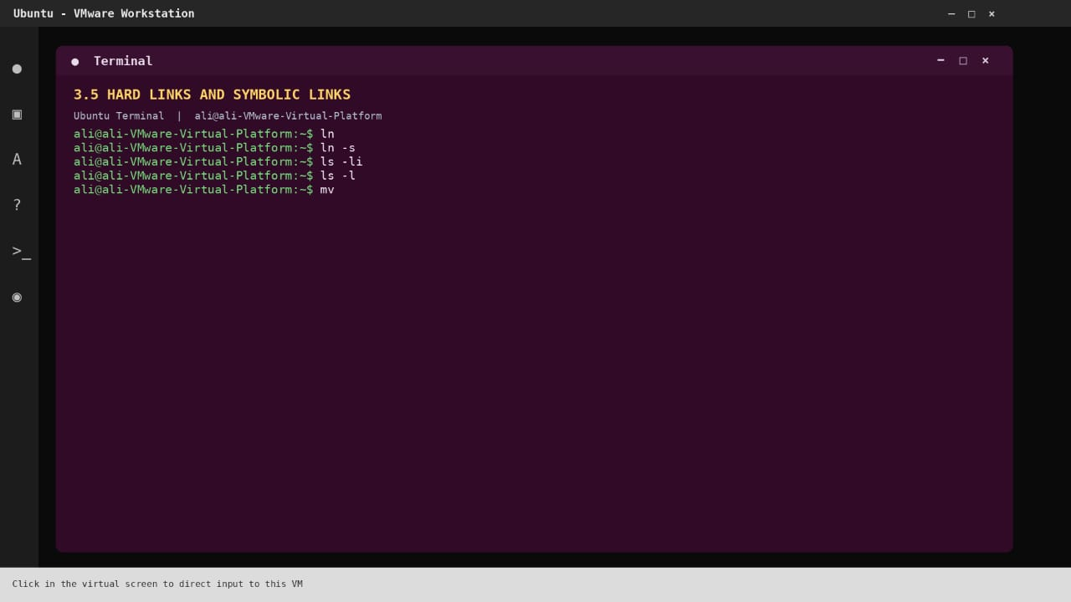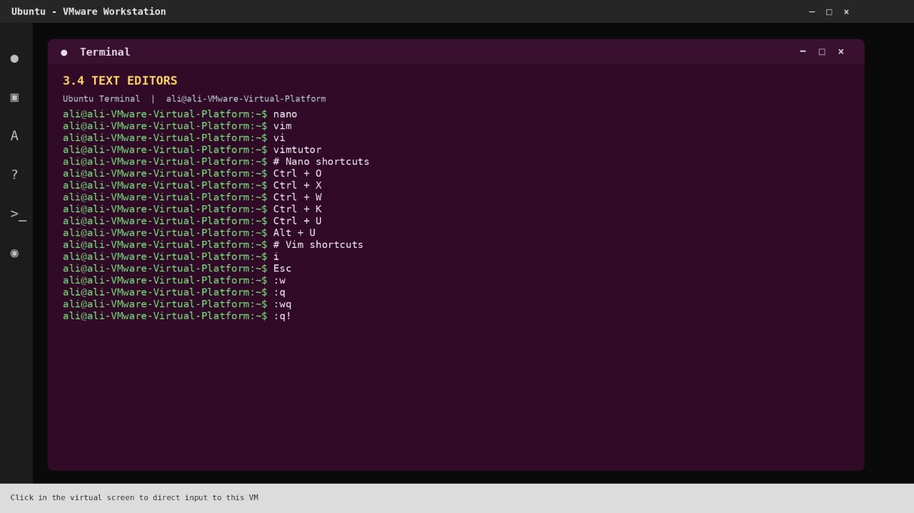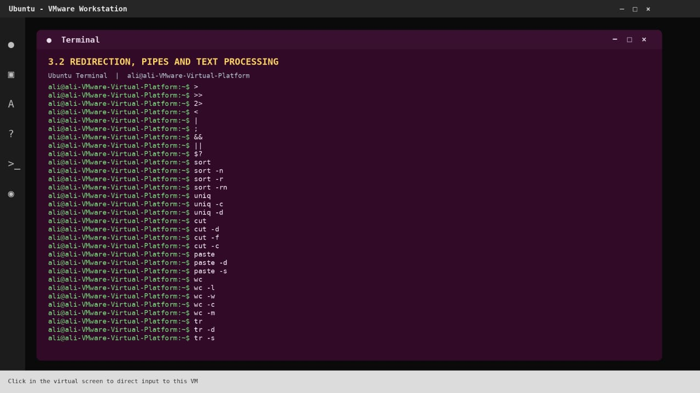
marka hore command kasta iisharax iyo options ka qaadan kar
CHAPTER 4 – LINUX COMMANDS
Waxaan kuu sharxayaa command kasta, waxa uu qabto, options-ka uu qaato iyo tusaalaha isticmaalka. Waxaan u kala qaadayaa 5 qaybood si ay kuugu fududaato barashada iyo diyaarinta imtixaanka.
4.1 Processes and Jobs
Qaybtan waxay ka hadlaysaa Processes (barnaamijyada socda) iyo Jobs (hawlaha Terminal-ka ka socda).
1. echo $$
- Shaqada: Wuxuu soo bandhigaa PID-ga Terminal-ka (shell process).
- Options: echo wuxuu leeyahay -n, -e, -E.
- $$ waa variable gaar ah oo muujinaya PID-ga shell-ka.
2. ps
- Shaqada: Wuxuu muujiyaa processes-ka socda.
- Options:
  - -e – Muuji dhammaan processes.
  - -f – Muuji faahfaahin dheeraad ah.
  - -u – Muuji processes-ka user gaar ah.
  - -p – Muuji process PID gaar ah.
  - -o – Dooro columns-ka aad rabto.
  - -a – Muuji processes-ka terminal-yada.
  - -x – Muuji processes aan lahayn terminal.
  - -l – Muuji faahfaahin dheer.
3. ps -f
- Shaqada: Wuxuu soo bandhigaa faahfaahinta processes-ka.
- Options: -f waa option-ka full format.
- Waxaa la isticmaali karaa -e, -u, -p, -o.
4. ps -o pid,ppid,comm
- Shaqada: Wuxuu soo bandhigaa PID, PPID iyo magaca command-ka.
- Options/columns:
  - pid – Process ID.
  - ppid – Parent Process ID.
  - comm – Magaca command-ka.
  - user – Magaca user-ka.
  - stat – Xaaladda process-ka.
  - cmd – Command-ka oo buuxa.
  - %cpu – CPU usage.
  - %mem – Memory usage.
5. ps -p 1 -o pid,comm
- Shaqada: Wuxuu muujiyaa process-ka leh PID 1.
- -p 1 – Dooro PID 1.
- -o – Dooro columns-ka la soo bandhigayo.
6. ps -p 1 -o pid,user,comm
- Shaqada: Wuxuu muujiyaa PID 1, user-kiisa iyo magaca process-ka.
- Options: -p, -o.
- user – Qofka ama account-ka process-ku ku shaqaynayo.
7. ps aux
- Shaqada: Wuxuu muujiyaa dhammaan processes-ka iyo CPU/Memory usage-kooda.
- a – Processes-ka terminal-yada.
- u – User-oriented format.
- x – Processes aan lahayn controlling terminal.
8. ps aux | less
- Shaqada: Wuxuu ku tusayaa dhammaan processes-ka si bog-bog ah.
- | – Pipe, wuxuu output-ka command-ka koowaad u gudbiyaa kan labaad.
- less – Waxaad kor iyo hoos ugu dhex socon kartaa qoraalka.
9. ps aux --sort=-%mem | head -n 5
- Shaqada: Wuxuu soo bandhigaa 5-ta process ee Memory-ga ugu badan isticmaalaya.
- --sort – Kala hormari.
- -%mem – Memory-ga ugu badan marka hore.
- head – Soo bandhig bilowga output-ka.
- -n 5 – Soo bandhig 5 lines.
10. ps -ef
- Shaqada: Wuxuu muujiyaa dhammaan processes-ka oo faahfaahsan.
- -e – Dhammaan processes.
- -f – Full format.
11. ps -ef | head -n 4
- Shaqada: Wuxuu soo bandhigaa 4-ta line ee ugu horreeya.
- head – Bilowga output-ka.
- -n 4 – Afar line.
12. ps -ef | less
- Shaqada: Wuxuu dhammaan processes-ka ku tusayaa bog-bog.
- less – Akhrinta output dheer.
13. pstree -p $$
- Shaqada: Wuxuu muujiyaa processes-ka qaab geed (tree) ah.
- -p – Muuji PID-yada.
- $$ – PID-ga shell-ka hadda socda.
14. top
- Shaqada: Wuxuu si toos ah ula socdaa processes-ka, CPU iyo RAM.
- Options:
  - -u USER – Muuji processes-ka user gaar ah.
  - -p PID – Muuji process gaar ah.
  - -d SEC – Bedel waqtiga cusboonaysiinta.
  - -n N – Tirada updates-ka.
  - -b – Batch mode.
  - -H – Muuji threads.
15. top -u student
- Shaqada: Wuxuu muujiyaa processes-ka user-ka student.
- -u – User filter.
- student – Magaca user-ka.
16. htop
- Shaqada: Waa process monitor la mid ah top, laakiin leh muuqaal fudud oo midabbo leh.
- Options:
  - -u USER – Filter user.
  - -p PID – Filter PID.
  - -t – Tree view.
  - -d N – Refresh delay.
  - -C – Monochrome mode.
  - -h – Help.
17. htop -u student
- Shaqada: Wuxuu muujiyaa processes-ka user-ka student.
- -u – User filter.
18. htop -t
- Shaqada: Wuxuu processes-ka u muujiyaa qaab tree ah.
- -t – Tree view.
19. command -v htop
- Shaqada: Wuxuu kuu sheegaa meesha command-ka htop laga heli karo.
- -v – Soo bandhig command-ka la helay.
20. sleep 30
- Shaqada: Wuxuu joojiyaa Terminal-ka 30 ilbiriqsi.
- Options: Waqti ayaa la siin karaa sida s, m, h, d.
- sleep 2m – 2 daqiiqo.
21. sleep 30 &
- Shaqada: Wuxuu sleep-ka ku socodsiiyaa background.
- & – Background operator, ma aha option.
22. sleep 100
- Shaqada: Wuxuu sugayaa 100 ilbiriqsi.
- Options: Waqtiga waxaa lagu qori karaa seconds, minutes, hours ama days.
23. jobs
- Shaqada: Wuxuu muujiyaa jobs-ka background-ka ku jira.
- Options:
  - -l – Muuji PID-ga job kasta.
  - -p – Muuji PID-yada oo keliya.
  - -r – Muuji jobs-ka socda.
  - -s – Muuji jobs-ka istaagay.
24. jobs -l
- Shaqada: Wuxuu muujiyaa jobs-ka iyo PID-yadooda.
- -l – Long format.
25. bg %1
- Shaqada: Wuxuu job number 1 ku bilaabaa background.
- bg – Background.
- %1 – Job number 1.
26. fg %2
- Shaqada: Wuxuu job number 2 ku soo celiyaa foreground.
- fg – Foreground.
- %2 – Job number 2.
27. fg
- Shaqada: Wuxuu job-kii ugu dambeeyay ee la yaqaan ku soo celiyaa foreground.
- Options: %job_number ayaa lagu dooran karaa job gaar ah.
28. gnome-calculator
- Shaqada: Wuxuu furaa Calculator-ka Ubuntu.
- Options: Ma laha options guud oo muhiim ah oo si joogto ah loo isticmaalo.
29. gnome-calculator &
- Shaqada: Wuxuu furaa Calculator-ka isagoo background ku shaqaynaya.
- & – Background operator.
4.2 Signals, Kill and Priority
Qaybtan waxay ka hadlaysaa sida loo joojiyo process, loo diro signals iyo sida loo beddelo mudnaanta process-ka.
1. kill -l
- Shaqada: Wuxuu soo bandhigaa dhammaan signals-ka Linux.
- Options:
  - -l – Liiska signals-ka.
  - -L – Liiska signals-ka oo qaab dheer ah.
2. kill -l 15
- Shaqada: Wuxuu kuu sheegaa magaca signal-ka number 15.
- -l – U beddel signal number magaciisa.
- 15 – SIGTERM.
3. kill PID
- Shaqada: Wuxuu joojiyaa process-ka PID-gaas leh.
- Options:
  - -TERM – Si caadi ah u jooji process-ka.
  - -KILL ama -9 – Si khasab ah u jooji.
  - -STOP – Jooji process-ka si ku-meel-gaar ah.
  - -CONT – Dib u sii wad process-ka.
4. kill -TERM PID
- Shaqada: Wuxuu process-ka u diraa signal SIGTERM si uu si caadi ah u istaago.
- -TERM – Signal number 15.
- PID – Process ID.
5. kill %1
- Shaqada: Wuxuu joojiyaa job number 1.
- %1 – Job-ka koowaad.
- Waxaa loo isticmaalaa jobs-ka shell-ka.
6. kill -9 PID
- Shaqada: Wuxuu si khasab ah u joojiyaa process-ka.
- -9 – SIGKILL.
- Ogow: Process-ku fursad uma helo inuu si caadi ah isu xiro ama xogtiisa kaydsado.
7. sudo kill -HUP PID
- Shaqada: Wuxuu process-ka u diraa SIGHUP.
- sudo – Ku fulin awood maamul.
- -HUP – Hangup signal.
- Waxaa badanaa loo isticmaalaa in adeeg dib u akhriyo configuration-kiisa, haddii uu taageero.
8. pgrep -a sleep
- Shaqada: Wuxuu raadiyaa processes-ka magacoodu yahay sleep.
- Options:
  - -a – Muuji PID iyo command-ka oo dhan.
  - -l – Muuji PID iyo magaca process-ka.
  - -u USER – Raadi processes-ka user gaar ah.
  - -x – Magaca saxda ah oo keliya.
  - -f – Ka raadi command line-ka oo dhan.
9. pkill -u student sleep
- Shaqada: Wuxuu joojiyaa processes-ka sleep ee user-ka student.
- Options:
  - -u – User gaar ah.
  - -9 – SIGKILL.
  - -TERM – SIGTERM.
  - -f – Ka raadi command line-ka oo dhan.
  - -x – Magac sax ah oo keliya.
10. killall sleep
- Shaqada: Wuxuu joojiyaa dhammaan processes-ka la yiraahdo sleep.
- Options:
  - -i – Weydii xaqiijin ka hor inta aan la dilin.
  - -I – Case-insensitive.
  - -q – Ha soo bandhigin fariimo.
  - -s SIGNAL – Dooro signal-ka.
  - -u USER – Dooro user gaar ah.
11. sleep 600 &
- Shaqada: Wuxuu bilaabaa sleep muddo 600 ilbiriqsi ah isagoo background ku jira.
- & – Background.
12. ps -p PID
- Shaqada: Wuxuu hubiyaa in process gaar ah weli socdo.
- -p – Dooro PID gaar ah.
13. ps -p PID -o pid,ppid,stat,cmd
- Shaqada: Wuxuu muujiyaa faahfaahinta process gaar ah.
- pid – Process ID.
- ppid – Parent Process ID.
- stat – Xaaladda process-ka.
- cmd – Command-ka.
14. nice
- Shaqada: Wuxuu maamulaa priority-ga process-ka marka la bilaabayo.
- Options:
  - -n VALUE – Dooro nice value.
  - --adjustment=VALUE – Sidoo kale wuxuu dejiyaa nice value.
- Nice value wuxuu u dhexeeyaa -20 ilaa 19.
- -20 – Mudnaan sare.
- 19 – Mudnaan hoose.
15. nice -n 10 sleep 300 &
- Shaqada: Wuxuu bilaabaa sleep isagoo leh nice value 10.
- -n 10 – Nice value 10.
- & – Background.
16. ps -o pid,ni,comm -p PID
- Shaqada: Wuxuu muujiyaa PID, nice value iyo magaca process-ka.
- pid – Process ID.
- ni – Nice value.
- comm – Command name.
- -p – Process gaar ah.
17. renice -n 15 -p PID
- Shaqada: Wuxuu beddelaa priority-ga process hore u socday.
- Options:
  - -n – Nice value cusub.
  - -p – Process ID.
  - -u – User gaar ah.
  - -g – Process group gaar ah.
18. renice -n 5 -p PID
- Shaqada: Wuxuu process-ka u beddelaa nice value 5.
- -n 5 – Nice value cusub.
- -p PID – Process-ka la beddelayo.
19. sudo renice -n 5 -p PID
- Shaqada: Wuxuu maamulka awood u siinayaa inuu beddelo priority-ga process-ka.
- sudo – Maamulaha system-ka.
- -n 5 – Nice value 5.
- -p – PID gaar ah.
20. top -p PID
- Shaqada: Wuxuu si toos ah ula socdaa process gaar ah.
- -p – Dooro PID.
- Waxaa kale oo jira -u, -d, -n, -b.
4.3 System Information
Qaybtan waxay ku saabsan tahay xogta computer-ka sida CPU, RAM, hard disk, kernel iyo network.
1. uname
- Shaqada: Wuxuu muujiyaa magaca operating system-ka/kernel-ka.
- Options:
  - -a – Dhammaan xogta.
  - -r – Kernel release.
  - -s – Kernel name.
  - -m – Machine hardware.
  - -n – Network hostname.
  - -v – Kernel version.
  - -p – Processor type.
  - -o – Operating system.
2. uname -r
- Shaqada: Wuxuu muujiyaa version-ka kernel-ka Linux.
- -r – Kernel release.
3. uname -m
- Shaqada: Wuxuu muujiyaa architecture-ka computer-ka.
- -m – Machine hardware name.
- Tusaale: x86_64.
4. uname -n
- Shaqada: Wuxuu muujiyaa magaca computer-ka ee network-ka.
- -n – Nodename.
5. uname -a
- Shaqada: Wuxuu soo bandhigaa dhammaan xogta uname.
- -a – All.
6. hostnamectl
- Shaqada: Wuxuu muujiyaa hostname iyo xogta system-ka.
- Options:
  - status – Muuji xogta hostname.
  - hostname – Muuji ama beddel hostname.
  - set-hostname NAME – Beddel magaca computer-ka.
  - --static – Static hostname.
  - --transient – Transient hostname.
  - --pretty – Pretty hostname.
7. hostnamectl hostname
- Shaqada: Wuxuu muujiyaa magaca hostname-ka.
- hostname – Subcommand-ka lagu arko ama lagu beddelo hostname.
8. uptime
- Shaqada: Wuxuu muujiyaa muddada computer-ku shaqaynayay.
- Options:
  - -p – Pretty format.
  - -s – Waqtigii system-ku bilaabmay.
  - -V – Version.
9. uptime -p
- Shaqada: Wuxuu muujiyaa muddada computer-ku shaqaynayay qaab fudud.
- -p – Pretty.
10. uptime -s
- Shaqada: Wuxuu muujiyaa waqtigii ugu dambeeyay ee computer-ku boot gareeyay.
- -s – Since.
11. nproc
- Shaqada: Wuxuu muujiyaa tirada CPU processing units ee la heli karo.
- Options:
  - --all – Muuji dhammaan processing units.
  - --ignore=N – Ka jar tirada N processing units.
12. free -h
- Shaqada: Wuxuu muujiyaa RAM iyo Swap memory.
- Options:
  - -h – Human-readable.
  - -m – MB.
  - -g – GB.
  - -k – KB.
  - -b – Bytes.
  - -s N – Cusboonaysii N ilbiriqsi kasta.
  - -t – Ku dar total.
13. free -m
- Shaqada: Wuxuu RAM iyo Swap ku muujiyaa megabytes.
- -m – Megabytes.
14. free -h -s 2
- Shaqada: Wuxuu RAM ku muujiyaa human-readable, wuxuuna cusboonaysiiyaa 2 ilbiriqsi kasta.
- -h – Human-readable.
- -s 2 – Refresh every 2 seconds.
- Jooji adigoo riixaya Ctrl + C.
15. lscpu
- Shaqada: Wuxuu soo bandhigaa xogta CPU-ga.
- Options:
  - -a – Dhammaan CPUs.
  - -b – Online CPUs.
  - -c – Offline CPUs.
  - -e – Extended format.
  - -p – Parsable format.
  - -J – JSON output.
16. lscpu | less
- Shaqada: Wuxuu xogta CPU ku tusayaa bog-bog.
- | – Pipe.
- less – Akhri output dheer.
17. lsblk
- Shaqada: Wuxuu muujiyaa disks iyo partitions-ka computer-ka.
- Options:
  - -a – Dhammaan devices.
  - -f – File systems.
  - -m – Permissions iyo ownership.
  - -o – Dooro columns.
  - -p – Full device paths.
  - -d – Ha muujin partitions.
  - -e N – Ka reeb device major number N.
  - -l – List format.
  - -J – JSON format.
18. lsblk -e 7
- Shaqada: Wuxuu muujiyaa block devices isagoo ka reebaya devices-ka major number 7 (badanaa loop devices).
- -e 7 – Exclude major number 7.
19. lsblk -e 7 -d -o NAME,SIZE,MODEL
- Shaqada: Wuxuu muujiyaa magaca disk-ka, cabbirkiisa iyo model-kiisa.
- -e 7 – Ka reeb loop devices.
- -d – Muuji disks oo keliya, ha muujin partitions.
- -o – Dooro columns.
- NAME – Magaca disk-ka.
- SIZE – Cabbirka disk-ka.
- MODEL – Model-ka disk-ka.
20. ls /proc
- Shaqada: Wuxuu muujiyaa xogta virtual filesystem-ka /proc.
- Options-ka ls:
  - -a – Hidden files.
  - -l – Long listing.
  - -h – Human-readable sizes.
  - -R – Recursive listing.
  - -t – Sort by time.
  - -S – Sort by size.
21. ls -l /proc/meminfo
- Shaqada: Wuxuu muujiyaa macluumaadka faylka meminfo.
- -l – Long listing.
- /proc/meminfo – Xogta RAM-ka.
22. cat /proc/uptime
- Shaqada: Wuxuu muujiyaa waqtiga system-ku shaqaynayay iyo idle time.
- cat options:
  - -n – Number lines.
  - -b – Number non-empty lines.
  - -A – Show hidden characters.
  - -s – Suppress repeated blank lines.
23. cat /proc/loadavg
- Shaqada: Wuxuu muujiyaa system load averages (1, 5 iyo 15 daqiiqo).
24. ls /proc/$$
- Shaqada: Wuxuu muujiyaa faylasha iyo xogta process-ka Terminal-ka hadda socda.
- $$ – PID-ga shell-ka.
25. head -n 7 /proc/$$/status
- Shaqada: Wuxuu muujiyaa 7-da line ee ugu horreeya xogta status-ka process-ka.
- -n 7 – Toddoba line.
- head options:
  - -n N – Tirada lines.
  - -c N – Tirada bytes.
  - -q – Ha soo bandhigin headers.
  - -v – Had iyo jeer muuji headers.
26. cat /proc/1/comm
- Shaqada: Wuxuu muujiyaa magaca process-ka PID 1.
- /proc/1/comm – Magaca process-ka koowaad.
27. grep -m 1 "model name" /proc/cpuinfo
- Shaqada: Wuxuu raadiyaa magaca model-ka CPU-ga.
- Options:
  - -i – Ignore uppercase/lowercase.
  - -n – Number lines.
  - -c – Count matches.
  - -v – Invert match.
  - -r – Recursive search.
  - -m N – Jooji marka N matches la helo.
  - -w – Match whole word.
  - -E – Extended regular expressions.
28. grep -c ^processor /proc/cpuinfo
- Shaqada: Wuxuu tirinayaa processor entries-ka CPU-ga.
- -c – Count.
- ^processor – Lines ku bilaabma processor.
29. head -n 3 /proc/meminfo
- Shaqada: Wuxuu muujiyaa saddexda line ee ugu horreeya xogta RAM-ka.
- -n 3 – Saddex line.
30. ls /sys
- Shaqada: Wuxuu muujiyaa xogta kernel-ka ee ku jirta /sys.
31. ls /sys/block
- Shaqada: Wuxuu muujiyaa block devices-ka sida disks-ka.
32. ls /sys/class/net
- Shaqada: Wuxuu muujiyaa network interfaces-ka computer-ka.
- Tusaale: lo, enp0s3.
33. cat /sys/class/net/enp0s3/address
- Shaqada: Wuxuu muujiyaa MAC address-ka network interface-ka enp0s3.
- cat – Akhri faylka.
4.4 Services with systemd
Qaybtan waxay ka hadlaysaa Services (adeegyada system-ka), sida SSH iyo Cron, iyo sida loo bilaabo, loo joojiyo ama loo hubiyo.
1. ps -p 1 -o pid,comm
- Shaqada: Wuxuu hubiyaa process-ka PID 1.
- -p 1 – Dooro PID 1.
- -o – Dooro columns.
- pid – Process ID.
- comm – Process name.
- Badanaa PID 1 waa systemd ee Ubuntu.
2. systemctl cat cron
- Shaqada: Wuxuu soo bandhigaa configuration-ka service-ka cron.
- Options:
  - cat – Akhri unit files.
  - status – Hubi xaaladda service.
  - start – Bilaab service.
  - stop – Jooji service.
  - restart – Dib u bilow.
  - reload – Dib u akhri configuration.
  - enable – Ka dhig inuu boot-ka bilaabmo.
  - disable – Ka jooji inuu boot-ka bilaabmo.
  - list-units – Muuji units.
3. systemctl status cron
- Shaqada: Wuxuu muujiyaa xaaladda service-ka cron.
- Options:
  - --no-pager – Ha isticmaalin pager.
  - --full – Muuji qoraalka oo dhan.
  - -l – Ha jarin lines-ka.
  - --user – User services.
4. systemctl is-active cron
- Shaqada: Wuxuu hubiyaa in cron hadda shaqaynayo.
- is-active – Hubi active/inactive.
5. systemctl is-enabled cron
- Shaqada: Wuxuu hubiyaa in cron loo diyaariyay inuu si toos ah u bilaabmo marka computer-ku boot gareeyo.
- is-enabled – Hubi enabled/disabled.
6. sudo systemctl stop cron
- Shaqada: Wuxuu joojiyaa service-ka cron.
- sudo – Maamul ahaan u fulin.
- stop – Jooji service.
7. sudo systemctl start cron
- Shaqada: Wuxuu bilaabaa service-ka cron.
- start – Bilaab service.
8. sudo systemctl restart cron
- Shaqada: Wuxuu joojiyaa kadibna dib u bilaabaa cron.
- restart – Dib u bilow.
9. systemctl show -p MainPID cron
- Shaqada: Wuxuu muujiyaa Main PID-ga service-ka cron.
- Options:
  - show – Muuji properties.
  - -p – Dooro property gaar ah.
  - MainPID – PID-ga ugu weyn ee service-ka.
10. sudo systemctl reload ssh
- Shaqada: Wuxuu ka codsadaa SSH service inuu dib u akhriyo configuration-kiisa.
- reload – Dib u akhri configuration adigoon service-ka si buuxda u joojin.
11. sudo systemctl reload cron
- Shaqada: Wuxuu cron ka codsadaa inuu dib u akhriyo configuration-kiisa.
- reload – Reload service.
12. sudo systemctl reload-or-restart cron
- Shaqada: Haddii service-ku taageero reload wuu reload-gareeyaa; haddii kale wuu restart-gareeyaa.
- reload-or-restart – Reload ama restart.
13. sudo systemctl disable cron
- Shaqada: Wuxuu ka joojiyaa cron inuu si automatic ah u bilaabmo marka system-ku boot gareeyo.
- disable – Ka saar automatic startup.
- Ogow: Ma joojinayo service-ka hadda socda.
14. sudo systemctl enable --now cron
- Shaqada: Wuxuu cron ka dhigaa inuu boot-ka bilaabmo, isla markaana hadda bilaabaa.
- enable – Automatic startup.
- --now – Hadda bilaab.
15. systemctl list-units --type=service --state=running
- Shaqada: Wuxuu muujiyaa services-ka hadda socda.
- Options:
  - list-units – Liiska system units.
  - --type=service – Services oo keliya.
  - --state=running – Kuwa socda oo keliya.
  - --all – Dhammaan units.
  - --failed – Units fashilmay.
16. systemctl list-units --type=service --state=failed
- Shaqada: Wuxuu muujiyaa services-ka fashilmay.
- --type=service – Services oo keliya.
- --state=failed – Kuwa fashilmay oo keliya.
4.5 Logs, Boot and Troubleshooting
Qaybtan waxay ku saabsan tahay Logs (diiwaannada system-ka), boot-ka computer-ka iyo baaritaanka ciladaha Linux.
1. journalctl -n 3
- Shaqada: Wuxuu muujiyaa 3-da log ee ugu dambeeya.
- Options:
  - -n N – Tirada log lines.
  - -b – Logs-ka boot-ka hadda.
  - -k – Kernel logs.
  - -u – Service gaar ah.
  - -f – Live follow.
  - -p – Priority gaar ah.
  - -e – U bood dhammaadka logs-ka.
  - -x – Muuji sharaxaad dheeraad ah.
  - --since – Logs laga bilaabo waqti gaar ah.
  - --until – Logs ilaa waqti gaar ah.
  - --no-pager – Ha isticmaalin pager.
2. journalctl -b
- Shaqada: Wuxuu muujiyaa logs-ka boot-ka hadda socda.
- -b – Current boot.
- -b -1 – Boot-kii ka horreeyay.
- -b -2 – Laba boot ka hor.
3. journalctl -b -p err
- Shaqada: Wuxuu muujiyaa error logs-ka boot-ka hadda.
- -b – Current boot.
- -p err – Error priority.
4. journalctl -u cron -n 4
- Shaqada: Wuxuu muujiyaa 4-ta log ee ugu dambeeya ee cron.
- -u cron – Dooro service cron.
- -n 4 – Afar log.
5. journalctl -u cron --since "1 hour ago"
- Shaqada: Wuxuu muujiyaa logs-ka cron ee saacaddii ugu dambeysay.
- -u – Dooro service.
- --since – Waqtiga laga bilaabayo.
- "1 hour ago" – Hal saac ka hor.
6. journalctl -u ssh -n 20
- Shaqada: Wuxuu muujiyaa 20-ka log ee ugu dambeeya ee SSH.
- -u ssh – SSH service.
- -n 20 – 20 lines.
7. journalctl -xe
- Shaqada: Wuxuu muujiyaa logs-ka dhammaadka iyo faahfaahin dheeraad ah.
- -x – Explanatory information.
- -e – U bood dhammaadka journal-ka.
8. journalctl -f
- Shaqada: Wuxuu si toos ah ula socdaa logs cusub.
- -f – Follow.
- Ctrl + C – Jooji la socodka.
9. logger "week 8 test from student"
- Shaqada: Wuxuu qoraal ku daraa system log.
- Options:
  - -p – Dooro priority.
  - -t – Dooro tag.
  - -i – Ku dar PID.
  - -s – Ku muuji fariinta Terminal-ka.
  - -f FILE – Ka akhri fariinta file.
10. journalctl -u cron -f
- Shaqada: Wuxuu si toos ah ula socdaa logs-ka cron.
- -u cron – Cron service.
- -f – Follow.
11. ls /var/log
- Shaqada: Wuxuu muujiyaa files-ka logs-ka ee Linux.
- Options:
  - -l – Long listing.
  - -a – Hidden files.
  - -h – Human-readable.
  - -R – Recursive.
  - -t – Sort by time.
  - -S – Sort by size.
12. less /var/log/syslog
- Shaqada: Wuxuu kuu oggolaanayaa inaad akhrido syslog bog-bog.
- Options:
  - -N – Muuji line numbers.
  - -S – Jooji line wrapping.
  - -F – Ka bax haddii file-ku hal screen ku jiro.
  - -R – Muuji ANSI colors.
- q – Ka bax less.
13. tail -n 3 /var/log/kern.log
- Shaqada: Wuxuu muujiyaa 3-da line ee ugu dambeeya kernel log.
- Options:
  - -n N – Tirada lines.
  - -c N – Tirada bytes.
  - -f – La soco xog cusub.
  - -F – La soco xitaa haddii file-ka la beddelo ama dib loo abuuro.
  - -q – Ha muujin headers.
  - -v – Muuji headers.
14. tail -f /var/log/syslog
- Shaqada: Wuxuu si toos ah ula socdaa syslog marka xog cusub lagu daro.
- -f – Follow.
- Ctrl + C – Jooji.
15. grep sudo /var/log/auth.log | tail -n 1
- Shaqada: Wuxuu raadiyaa qoraalka sudo ee auth.log, kadibna muujiyaa hal line ee ugu dambeeya.
- grep – Raadi qoraal.
- sudo – Qoraalka la raadinayo.
- | – Pipe.
- tail -n 1 – Hal line ee ugu dambeeya.
16. journalctl _COMM=sudo -n 1
- Shaqada: Wuxuu muujiyaa hal log ee ugu dambeeya ee command-ka sudo.
- _COMM=sudo – Filter magaca process-ka.
- -n 1 – Hal log.
17. last -n 2
- Shaqada: Wuxuu muujiyaa labadii user ee ugu dambeeyay ee login sameeyay.
- Options:
  - -n N – Tirada entries.
  - -a – Hostname-ka dhig dhammaadka.
  - -F – Muuji full login iyo logout times.
  - -x – Muuji system shutdown iyo runlevel changes.
  - -i – Muuji IP address.
18. sudo dmesg
- Shaqada: Wuxuu muujiyaa fariimaha kernel-ka.
- Options:
  - -T – Muuji waqtiga la akhrin karo.
  - -H – Human-readable output.
  - -l – Dooro log level.
  - -f – Dooro facility.
  - -w – Sug fariimo cusub.
  - -c – Akhri oo nadiifi kernel ring buffer (waxay ku xiran tahay nidaamka).
19. sudo dmesg -T | tail -n 2
- Shaqada: Wuxuu muujiyaa labada fariimood ee ugu dambeeya kernel-ka, isagoo waqtiga ka dhigaya mid la fahmi karo.
- -T – Human-readable timestamps.
- tail -n 2 – Labada line ee ugu dambeeya.
20. sudo dmesg | less
- Shaqada: Wuxuu kernel messages ku tusayaa bog-bog.
- | – Pipe.
- less – Akhris bog-bog.
21. journalctl -k -b
- Shaqada: Wuxuu muujiyaa kernel logs-ka boot-ka hadda.
- -k – Kernel messages.
- -b – Current boot.
22. sudo shutdown -r +5 "Rebooting for the lab"
- Shaqada: Wuxuu jadwaleeyaa in computer-ku dib u bilaabmo 5 daqiiqo kadib.
- Options:
  - -r – Reboot.
  - -h – Halt.
  - -P – Power off.
  - -c – Cancel scheduled shutdown.
  - +5 – Shan daqiiqo kadib.
  - now – Hadda.
  - "Rebooting for the lab" – Fariinta dadka system-ka isticmaalaya.
23. sudo shutdown -c
- Shaqada: Wuxuu baajiyaa shutdown ama reboot hore loo jadwaleeyay.
- -c – Cancel.
24. sudo reboot
- Shaqada: Wuxuu dib u bilaabaa computer-ka.
- Options:
  - -f – Force reboot (isticmaal taxaddar).
  - --help – Help.
  - --no-wall – Ha dirin digniinta users-ka.
25. sudo poweroff
- Shaqada: Wuxuu damiyaa computer-ka.
- Options:
  - -f – Force poweroff.
  - --help – Help.
  - --no-wall – Ha dirin digniin.
26. systemctl status ssh
- Shaqada: Wuxuu hubiyaa xaaladda SSH service-ka.
- status – Muuji xaaladda.
- --no-pager – Ha isticmaalin pager.
- -l – Muuji lines-ka oo dhan.
27. journalctl -u ssh -n 30
- Shaqada: Wuxuu muujiyaa 30-ka log ee ugu dambeeya SSH.
- -u ssh – SSH service.
- -n 30 – 30 logs.
28. ls /etc/ssh
- Shaqada: Wuxuu muujiyaa configuration files-ka SSH.
- ls options:
  - -l – Long listing.
  - -a – Hidden files.
  - -h – Human-readable.
  - -R – Recursive.
29. sudo sshd -t
- Shaqada: Wuxuu hubiyaa in SSH server configuration-ku sax yahay.
- Options:
  - -t – Test configuration.
  - -T – Test configuration oo muuji effective configuration.
  - -f FILE – Dooro configuration file.
  - -p PORT – Dooro port.
30. top
- Shaqada: Wuxuu la socdaa CPU, RAM iyo processes-ka socda.
- Options:
  - -u USER – User gaar ah.
  - -p PID – Process gaar ah.
  - -d N – Refresh interval.
  - -n N – Tirada updates.
  - -b – Batch mode.
  - -H – Threads.
Muhiim: Calaamadaha iyo erayada aad fahmi karto
Calaamad/Eray | Macnaha
PID | Process ID; number-ka process-ka
PPID | Parent Process ID
& | Background
\| | Pipe
sudo | Ku shaqee awood maamul
-n | Number ama count, iyadoo command-ku ku xiran yahay
-p | Process, property ama priority, iyadoo command-ku ku xiran yahay
-f | Full, follow ama file, iyadoo command-ku ku xiran yahay
-h | Help ama human-readable
-r | Reboot ama release, iyadoo command-ku ku xiran yahay
-a | All
-l | List ama long format
Waxyaabaha imtixaanka muhiimka u ah
Xusuusnow
- ps – Show running processes.
- top – Monitor processes.
- kill – Terminate a process.
- nice – Set process priority.
- renice – Change process priority.
- uname – Show system information.
- free – Show memory usage.
- lscpu – Show CPU information.
- lsblk – Show block devices.
- systemctl – Manage services.
- journalctl – View system logs.
- dmesg – Show kernel messages.
- shutdown – Shut down or reboot system.
- reboot – Restart system.
- poweroff – Turn off system.
Laba arrimood oo aad taxaddarto:
- PID, USER, iyo student waa placeholders ama magacyo tusaale ah. Ku beddel qiimaha dhabta ah ee computer-kaaga.
- kill -9, sudo reboot, iyo sudo poweroff si taxaddar leh u isticmaal.
Tani waa sharaxaadda Chapter 4 oo dhan: 4.1 ilaa 4.5. Options-ka qaar waxay ku kala duwanaan karaan nooca Linux iyo utility-ga la rakibay.



